Contents

Acknowledgments iii
List of Figures viii
Abbreviations ix
Abstract x
- Introduction 1
  - Problem Statement 1
  - Objectives 1
  - Scope and Limitations 3
    - Scope 3
    - Contributions to Sustainable Development Goals (SDGs) 3
    - Limitations 5
- Literature Review 7
  - Overview of Holographic Display Technologies 7
  - Pepper’s Ghost Theory in 3D Visualization 7
  - Gesture Recognition through Computer Vision 8
  - Integration of Mobile Applications with Embedded Systems 9
  - Firebase as a Cloud-Based Communication Channel 9
- System Architecture and Components 11
  - Conceptual Overview of 3D Holographic Display 12
  - Pepper’s Ghost Prism Design 13
  - Interaction Modes: Gestures vs App Buttons 14
    - Gesture-Based Interaction 14
    - Button interaction on App 14
  - Firebase Cloud Communication Architecture 16
  - Overview of Real-Time Media Control System 17
  - Architectural Layers Diagram 18
- Hardware and Software Components 19
  - Hardware Requirements and Setup 19
    - Laptop and Internal Camera 19
v
    - Prism Construction and Display Platform 20
  - Software Stack 22
    - Python with MediaPipe and OpenCV 22
    - Tkinter and CustomTkinter GUI Design 23
    - Command Sync Integration Using Firebase 26
    - Mobile App Framework and Control Logic 27
- System Implementation 32
  - Gesture Recognition and Algorithms 32
  - Image Capture and Delivery Performance 34
  - App-Firebase-Python Synchronization Workflow 35
  - Media Player Class Architecture 36
  - Zoom and Navigation Gesture Functions: 37
  - Threading and Real-Time Gesture Feedback 38
  - Error Handling and System Robustness 39
- Testing and Evaluation 41
  - Gesture Detection Accuracy 41
  - Response Time for Commands (Gesture vs App) 42
  - Media Playback Smoothness 43
  - Synchronization Latency with Firebase 44
  - Limitations in Detection and Media Control 45
  - Summary and Implications: 46
- Results and Discussion 47
  - Gesture Recognition Performance Analysis 47
  - User Interaction Mode Evaluation 48
  - Pepper’s Ghost Display Effectiveness 50
  - Advantages and Disadvantages of Utilizing Firebase 51
  - General Discussion 52
- Future Work and Enhancements 54
  - Technical Constraints and Challenges Encountered 54
  - Proposed Enhancements 56
    - Gesture Classification Using Deep Learning 56
    - Voice Command Support 57
    - Mobile App with AR Preview 58
    - Multi-user Interaction Support 58
- Conclusion 60
  - Summary of Project Contributions 60
  - Main Technical Results 61
  - Practical Applications 62
  - Closing Remarks 64
A Appendix 66
  - Code Snippets 66
    - node.py 66
    - firebase key.json 77
References 80

List of Figures

  - System Architecture 11
  - System Flow Diagram 12
  - Pepper’s Ghost Prism Design 13
  - Visualization of Hand Landmarks for Gesture Recognition 14
  - Architectural Layers of System 18
  - Webcam 20
  - Acrylic Sheets 21
  - LCD 21
  - HDMI to VGA Converter 22
  - Gesture and App-Controlled Media Flowchart 29

viii

Abbreviations

GUI Graphical User Interface IoT Internet of Things
LCD Liquid Crystal Display RGB Red Green Blue
MP4 MPEG-4 Video Format
JPEG Joint Photographic Experts Group PNG Portable Network Graphics
FPS Frames Per Second
PIL Python Imaging Library
API Application Programming Interface HD High Definition
SDK Software Development Kit
MIT Massachusetts Institute of Technology

ix

Abstract
In an age where digital interaction is rapidly evolving, traditional flat screens are no longer the only way to experience visual content. From augmented reality to holography, the desire for more immersive and intuitive interfaces is becoming mainstream. This project explores the design and implementation of an inter-active 3D holographic display system that bridges visual immersion with user-friendly control. What makes this system unique is that it merges two modern technologies—gesture control and mobile-based remote commands—into a single setup powered by computer vision, holographic illusion techniques, and real-time data synchronization.
The centerpiece of this project is a transparent pyramid-shaped display, built using the Pepper’s Ghost principle, a classic illusion technique that gives digital content a floating, three-dimensional appearance. Four mirrored versions of the same image or video are projected from different angles onto the pyramid’s faces, creating the illusion of a 3D object suspended in the center. What’s compelling is that this visual trick can be achieved with low-cost materials—such as acrylic sheets and a standard display screen—making it both practical and affordable.
To make the system interactive, two control methods are implemented. The first is hand gesture recognition through a standard laptop webcam. By using Me-diaPipe’s hand tracking module along with OpenCV, the system can detect and respond to specific hand movements. For example, an open hand gesture might rotate the hologram, while pinching gestures can zoom in or out. These gestures are processed in real-time, offering an intuitive and touch-free way to control the holographic content. The second control mechanism is a mobile application devel-oped using MIT App Inventor, which provides users with clearly labeled buttons (e.g., Zoom In, Zoom Out, Next, Previous, Rotate). When a button is pressed, a command is sent to a Firebase Realtime Database, which syncs instantly with the main display system running on a laptop.
On the software side, the core logic is written in Python, using Tkinter and Cus-tomTkinter for the graphical user interface. The app displays pre-processed images

Abstract xi

and videos in the correct orientation for holographic projection. To ensure smooth and responsive performance, the application uses multithreading—so that gesture tracking, Firebase monitoring, and UI updates run in parallel without causing any lag or delays. This design decision significantly enhances the user experience, especially when switching between controls or rendering high-resolution media.
During development, a number of technical challenges were addressed. For in-stance, ambient lighting had a notable impact on gesture accuracy, requiring ad-justments to the background filters and hand detection sensitivity. Similarly, en-suring real-time synchronization with Firebase demanded careful error handling and optimization of read/write cycles. Despite these challenges, the final system performs reliably under typical indoor lighting and offers a seamless user experi-ence across both control methods.
Beyond the prototype, this technology holds great potential across various do-mains. In education, such a system can be used to display interactive 3D models of molecules, organs, or historical artifacts. In retail, it could serve as a futuristic way to showcase products. In entertainment or art galleries, it offers an engag-ing medium to deliver visual storytelling. And because the project is built with open-source tools and inexpensive hardware, it’s highly scalable and customizable.
Looking ahead, future improvements could include integrating voice control, en-hancing gesture recognition using machine learning, or connecting multiple devices over a local network for synchronized displays. The addition of auto-calibration for different lighting environments and content scheduling features would further enhance its utility in professional settings.
In conclusion, this project demonstrates that a low-cost, interactive 3D holographic system is not only feasible but also highly functional when designed with the right combination of hardware simplicity and software intelligence. By blending classic illusion techniques with modern interaction technologies, it provides a glimpse into the future of digital display— one where content floats in mid-air and responds to your hand or phone, making interaction feel almost magical.

Chapter 1 Introduction

Problem Statement
With the advent of immersive and interactive technologies transforming user expe-riences, the classical 2D media screens seem static and constrictive. More engaging and intuitive interaction with digital content is what viewers tend to desire. Cur-rent systems such as touch interfaces or mouse-keyboard combinations are physical to interact with, hence less convenient for hands-free situations or advanced ap-plications such as smart classrooms, museums, exhibitions, or hospital displays.
The issue solved in this project is the lack of an inexpensive, gesture-controlled interactive 3D holographic media display system allowing users to move around, zoom, and touch visual material without direct contact. Additionally, there should be real-time synchronization between remote mobile devices and the holographic system for remote control.

Objectives
The overall objective of this project is to develop a pioneering, cost-effective, and easy-to-use 3D holographic display system utilizing cutting-edge gesture recogni-tion technology and cloud-based synchronization. The main objectives include:

- Design and Fabrication of Pepper’s Ghost Prism: One of the key goals is to create a Pepper’s Ghost prism physically from transparent acrylic sheets. The structure should maximize optical qualities in order to achieve

1

the maximum holographic illusion. This encompasses accurate measure-ments, material choice, and assembly processes to provide clarity, little dis-tortion, and robustness. The prism will constitute the central visual ele-ment that displays media content in a way that seems to levitate in three-dimensional space, thus offering an engaging user experience.
- Development of a Stable Gesture Recognition System: The project seeks to leverage Google’s MediaPipe Hands solution combined with OpenCV to develop an algorithm for real-time hand tracking and gesture recognition. The platform will recognize a pre-defined list of gestures—Next, Previous, Zoom In, and Zoom Out—to support natural, touchless interaction with me-dia content. This would include tuning parameters for gesture sensitivity, noise filtering, and high accuracy across varying environments.
- Development of an Interactive and Reactive GUI: With Python’s Tk-inter and its improved version CustomTkinter, a modern, intuitive, graphical interface will be built. The GUI should be able to have smooth switching between media, show images and videos properly rotated for the holographic prism, and react instantaneously to user input whether initiated by gestures or mobile app commands. The interface shall also have feedback components to assist users through interaction.
- Integration with Firebase for Cloud-Based Synchronization: To ex-pand the system capabilities beyond local user interaction, integration with Firebase Firestore will be used. This will enable a mobile app or other re-mote devices to transfer control commands that are reflected in real-time on the holographic display system. The goal here is low-latency, high-fidelity command synchronization that will accommodate collaborative or remote user settings.
- Implementation of Dual Interaction Modes: The system shall cater to gesture-based input and far-field button-based input using the mobile app. This two-mode capability addresses diverse user needs and environments to ensure convenience and accessibility. Users shall be able to switch between direct hand gestures and far-field commands with ease, promoting usability.
- Optimization for Smooth Multimedia Playback: Ensuring that im-ages and video both load, appear, and transition smoothly between the three display frames is paramount. This goal is media handling-oriented—proper resizing, rotation, and playback synchronization—to perpetuate the illusion and deliver a visually appealing experience without lag or jitter.

Scope and Limitations

Scope
      - Supported Media Types and Formats: The framework will natively support popular image formats like JPEG (.jpg) and PNG (.png), and video formats like MP4 (.mp4). The selection is based on pragmatic thinking in regards to file compatibility, availability of codecs, and processing. Sustain-ing these formats provides users with the ability to readily load and engage with the majority of standard media files.
      - Gesture Recognition Capabilities: Employing MediaPipe’s hand track-ing capability, the system will accurately identify a small, well-defined subset of hand gestures—Next, Previous, Zoom In, and Zoom Out. The gestures are selected for their natural suitability and applicability to media naviga-tion and control. By narrowing the gesture vocabulary, the system gains better recognition accuracy and lowers the probability of false positives.
      - Holographic Display Configuration: Media will be projected over three different frames corresponding to the four-sided Pepper’s Ghost prism (left, right, bottom). Each frame will project the media content with exact rota-tions (90°, -90°, 180°) to match the surfaces of the prism and produce the holographic effect. Multiple frames are necessary to produce a believable 3D floating image effect.
      - Mobile Synchronization through Firebase: The system supports Fire-base Firestore integration to enable real-time command synchronization be-tween the desktop holographic display and remote mobile devices. This allows for media playback control remotely, providing flexibility and greater application scenarios.
      - Local and Remote-Control Modes: The system has both direct gesture control and button-based input from a mobile application, and the user can select whichever mode of interaction they prefer. Dual-mode operation makes the system more accessible and helps to extend its use in varying environments.

Contributions to Sustainable Development Goals (SDGs)
The 3D Holographic Display System developed in this project not only pushes the boundaries of technological innovation but also aligns with the vision of the United

Nations Sustainable Development Goals (SDGs). By integrating computer vision, low-cost hardware, and interactive media, the system contributes directly and indirectly to several SDGs, particularly in education, health, industry innovation, and sustainable infrastructure.

Goal 4 – Quality Education:
This system can serve as an interactive learning tool in classrooms, muse-ums, and science exhibitions. The visual representation of complex struc-tures such as anatomical models, molecules, or historical artifacts makes learning more engaging and accessible. Through holographic visualization, students can interact with 3D models in a way that enhances retention and understanding, especially in STEM (Science, Technology, Engineering, and Math) education[8].

Goal 9 – Industry, Innovation and Infrastructure:
The system is a practical example of affordable innovation. By using open-source tools (Python, MediaPipe, Firebase) and low-cost materials (acrylic sheets, a standard webcam, and display), this project demonstrates that high-tech solutions can be developed in resource-limited environments. It promotes the idea of building inclusive and sustainable technology infrastruc-tures that are scalable and adaptable for various sectors such as healthcare, education, and exhibitions[12].

Goal 3 – Good Health and Well-being:
In the post-pandemic world, touch-free interfaces are gaining importance in ensuring hygiene and public safety. Our system provides a gesture-controlled interaction method that can be extended to public information kiosks, hospi-tals, and clinics where physical contact should be minimized. This supports safer environments, especially in healthcare setups, reducing the risk of germ transmission through shared touchscreens[11].

Goal 12 – Responsible Consumption and Production:
The design emphasizes resource-efficient engineering by reusing common electronics and focusing on minimal waste production. The use of modu-lar code, recycled display screens, and local fabrication methods supports sustainable consumption practices in prototyping and development[10].

Goal 11 – Sustainable Cities and Communities:
In smart cities, interactive digital displays and kiosks can serve citizens better with gesture-based public interfaces for maps, transit schedules, or

museum guides. This technology can promote cultural heritage, public en-gagement, and digital inclusion without requiring large budgets or complex infrastructure[9].

Limitations
There are several limitations that influence the performance and user experience of the system despite the grand scope:

      - Gesture Recognition Challenges: Vision-based gesture recognition is sensitive by nature to the environment. Lighting conditions, e.g., low illumi-nation or strong shadows, can decrease the accuracy of tracking. Dynamic or intricate backgrounds can lead to misdetections or loss of tracking. The system will need the user’s hand to be kept in the field of view of the camera and at close-tooptimal distance for consistent detection.
      - Physical Setup Constraints: The Pepper’s Ghost prism has to be pre-cisely aligned in proportion to the laptop display to allow the holographic illusion to be properly rendered. Any angle or misalignment can warp the projected image, destroying the 3D effect. Manual adjustment at initial setup can be necessary to meet the highest visual performance.
      - Zoom Limitations in Video Mode: In order to uphold video quality and avoid distortion, the zoom-in and zoom-out actions are blocked during video playback. This restricts user interaction ability when viewing video media since zooming is disallowed for image content only.
      - Dependency on Stable Network: The Firebase synchronization relies on a stable and uninterrupted internet connection. Disruptions, latency, or connectivity problems would hinder the propagation of commands, resulting in remote control response lag. The limitation would be consequential to system usability in the case of poor network infrastructure environments.
      - Hardware and Processing Constraints: The system operates from a standard laptop with a built-in webcam. Computational demands, especially when video playback in real-time is coupled with gesture detection, can impact performance. It can appear as frame drops or delay, and notably so, on less capable machines. Moreover, camera resolution and frame rate constraints affect fidelity of tracking.

      - Limited Gesture Vocabulary: The system now accommodates a limited number of gestures for ease of use and dependability. Although this con-tributes to accuracy, it also limits the extent of potential interaction. More intricate or sophisticated gestures are beyond the scope of the present solu-tion and would involve further development.

Chapter 2 Literature Review

Overview of Holographic Display Technolo-gies
Holographic display technology has evolved greatly over the past few years, with the promise of immersive, glasses-free 3D viewing. 3D displays were previously achieved with stereoscopic methods, but holography offers actual volumetric depth without the need for special glasses. Yara¸s et al. (2015) ”State of the Art in Holographic Display” review article describes the shift from static holograms to dynamic digital holography with spatial light modulators (SLMs), enabling real-time updating of images.
In recent deployments, as discussed in the submitted paper by Manaktala et al. (2023), attention is being diverted towards cost-effective and affordable holo-graphic display systems. Such systems employ simple reflectors and LCDs or TFT screens to project images onto pyramid-shaped prisms, creating the illusion of depth through the Pepper’s Ghost illusion[4].
Contemporary hologram systems are democratized and miniaturized with em-bedded microcontrollers (ESP32), low-power batteries, and simple displays, yet produce ever more realistic visual effects. This strategy compromises between portability, cost, and performance—particularly in education, medicine, and exhi-bition applications.

Pepper’s Ghost Theory in 3D Visualization
The Pepper’s Ghost illusion, developed in the 19th century for stage performances, is still a staple in current holographic configurations because of its elegance and

7

efficiency. It consists of projecting an image or video from a flat screen onto a transparent surface at an angle (most commonly 45°), with the perceived effect that the object appears to float in space.
As per the scenario of our project and discussed in Manaktala et al. (2023), the technique is performed with the help of a transparent pyramid consisting of acrylic or glass sheets. The material is presented from three or four directions, rotated correspondingly to look correct from every viewing point when reflected. This method is well-suited for handheld, DIY 3D displays as it circumvents real volumetric holography’s computational and hardware sophistication, but provides a rich visual experience nonetheless. In the survey conducted by Pan et al. (2022), while numerous researchers are targeting real light-field or SLM-based displays, Pepper’s Ghost is still applicable because of its low latency, simple calibration, and support for interactive experiences (LAM, 2022).

Gesture Recognition through Computer Vi-sion
Hand gesture recognition has transitioned from the utilization of dedicated hard-ware (e.g., gloves, infrared sensors) to software-based computer vision techniques employing standard RGB cameras. This change, addressed at length by the up-loaded paper and corroborated by extended literature (Pan et al., 2022), is at-tributed primarily to developments in deep learning and real-time processing li-braries such as MediaPipe.
MediaPipe Hands, created by Google, recognizes 21 landmarks on the hand with a twostage neural network pipeline consisting of a palm detector and a landmark estimator. In your system, swipe left/right and zoom in/out gestures are iden-tified using the landmarks’ coordinates and interpreted via velocity and spatial thresholds.
As indicated in [template+39.pdf] and the studies of IJESC cited therein, gesture control enhances the interactivity of holographic displays, becoming more intuitive and contactfree. This is especially helpful for hygienic or touch-free interfaces, such as for medical purposes, public installations, and educational installations.

Integration of Mobile Applications with Em-bedded Systems
Mobile app integration is also important in remote control and interaction with embedded systems. Embedding mobile apps as input controllers (over Wi-Fi, Bluetooth, or cloud) enables users to control embedded systems remotely. It has been used successfully in IoT systems, robotics, and smart home installations.
In your project, a MIT App Inventor-developed mobile application commands the Firebase Firestore database. This arrangement establishes a two-way communi-cation channel between the display system and the application, where the latest command is read from the cloud by the display system and causes corresponding actions in the media.
This solution reflects what was discussed in the uploaded PDF and various aca-demic documents, including the IJESC 2021 paper, that highlight the convenience and scalability of cloud-app-buried system integrations. Firebase, being real-time and cloud-based, is particularly well-aligned for such light-weighted, latency-sensitive engagements.

Firebase as a Cloud-Based Communication Channel
Firebase Firestore is used in this system for asynchronous, real-time communica-tion between the mobile app and desktop system.
Firebase provides a number of advantages:

    - Real-time updates via snapshot listeners
    - Low initialization delay and wide SDK support
    - Cross-device compatibility and cloud scalability
    - Platform independent communication (Android, Web,Python, etc.)

As per the downloaded research and evidence supported in light-based display studies (Su et al., 2021), the integration of Firebase or other cloud services into embedded applications makes them scalable, IoT-enabled systems. On your config-uration, the Firestore database is sent commands such as ”ZOOM IN”, ”NEXT”, or ”PREVIOUS” from a mobile app. These are immediately caught by the

Python GUI on the laptop courtesy of a listener function that listens to Firestore changes[6]. This architecture supports:

    - Remotely controlling holographic displays
    - Command queuing or logging
    - UI (mobile) decoupling and processing logic (PC/laptop)

Such a modular design complies with edge-cloud hybrid architectures suggested for smart display systems in articles such as Light: Science & Applications (Yara¸s et al., 2015; Lam, 2021).

Chapter 3

System Architecture and Components

This chapter presents the technical and conceptual design of the proposed 3D holographic display system. The system enables real-time, contactless interaction with media content using computer vision and optical illusion principles. It inte-grates technologies such as MediaPipe for gesture recognition, OpenCV for media processing, Firebase Firestore for remote communication, and a Python GUI built using Tkinter and CustomTkinter.
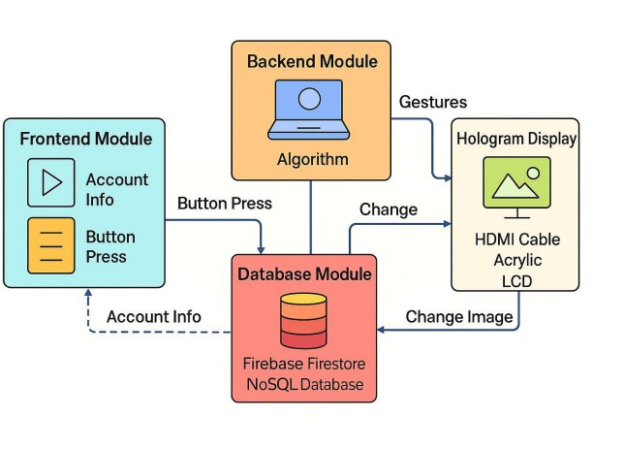
Figure 3.1: System Architecture

11

Conceptual Overview of 3D Holographic Dis-play
The system simulates a three-dimensional (3D) looking experience with two-dimensional (2D) media based on the Pepper’s Ghost optical illusion principle. A clear acrylic prism, positioned on top of an LCD screen, reflects images that look like they are suspended in space from the top perspective. This system does not use lasers or sophisticated projection technology, unlike conventional holography.
To communicate with the display, users make hand movements before a webcam. The movements are read by a Python application based on MediaPipe’s hand landmark model, detecting finger locations and gesture patterns. The application relies on OpenCV to read and process video frames in real time and displays the images in three rotated frames through a CustomTkinter GUI. The frames match the reflective faces of the prism.
The design features two-way control—users can either control directly through gestures or remotely through a mobile interface that issues commands through Firebase Firestore.
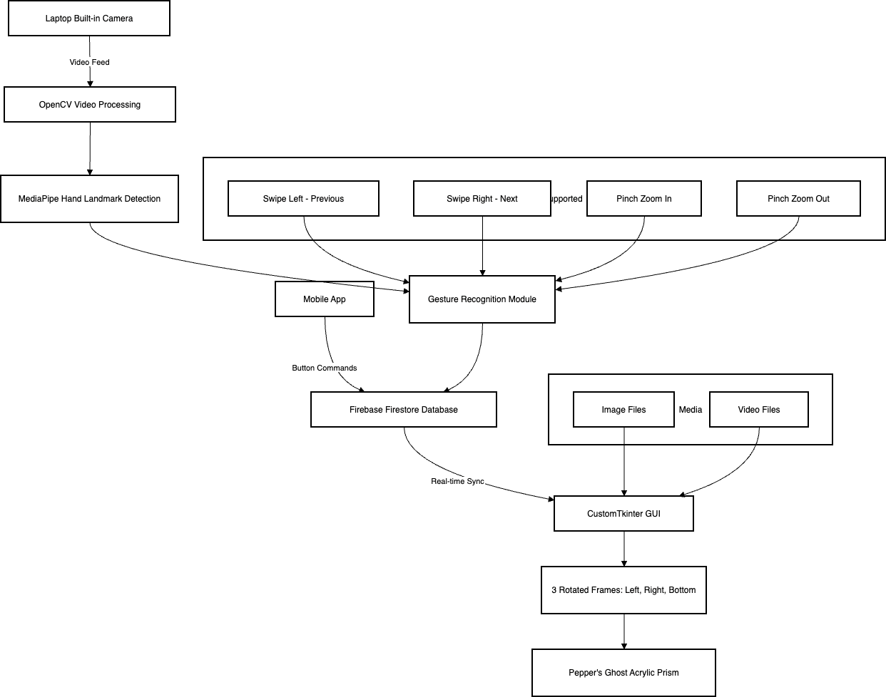

Figure 3.2: System Flow Diagram

Pepper’s Ghost Prism Design
Pepper’s Ghost technology is employed to produce the effect of floating images without employing high-end holographic hardware. This system creates the illu-sion using a foursided acrylic prism made of transparent plastic sheets cut and glued at an angle of about 45 degrees. The prism base is placed flush on a 19-inch Acer LCD display screen, where rotated images and videos are shown. Every side of the prism bounces a part of the screen to form a cohesive 3D visual effect from the top.
The graphic content is segmented into three major frames; each rotated as needed for the viewing angle to reflect correctly:

- Left Frame: +90◦ rotated to reflect correctly against the left-facing prism wall (Frame 1).
- Right Frame: −90◦ rotated for right wall reflection (Frame 2).
- Bottom Frame: 180◦ rotated to look upright when the front is viewed (

In order to enhance contrast and limit interference from natural light, the prism is encased in a wooden or cardboard box covered with black cloth

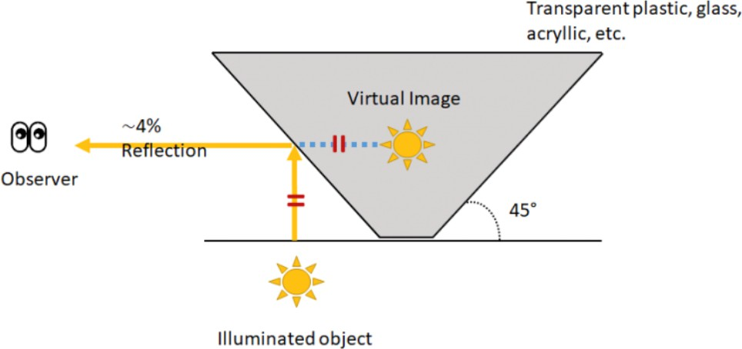

Figure 3.3: Pepper’s Ghost Prism Design

Interaction Modes: Gestures vs App But-tons
The In order to improve flexibility and ease of use, the system provides two inter-action modes: direct hand gesture input and app-based button control. Both are implemented in the same software backend in a module-based fashion.

Gesture-Based Interaction
Hand gestures are identified by a webcam placed on the laptop. A frame is taken with OpenCV and processed with MediaPipe Hands, which detects 21 landmarks on the hands. The landmarks are used to identify particular gesture patterns like swipes and pinches.
The following gestures are supported by the system:

      - Swipe Right: Nvaigates to next media item
      - Swipe Left: Moves back to previous media item
      - Pinch Out: Zooms in the played image
      - Pinch In: Zoom out, minimizes the display size

Each identified gesture is mapped to a command that directly updates the GUI and the media state.
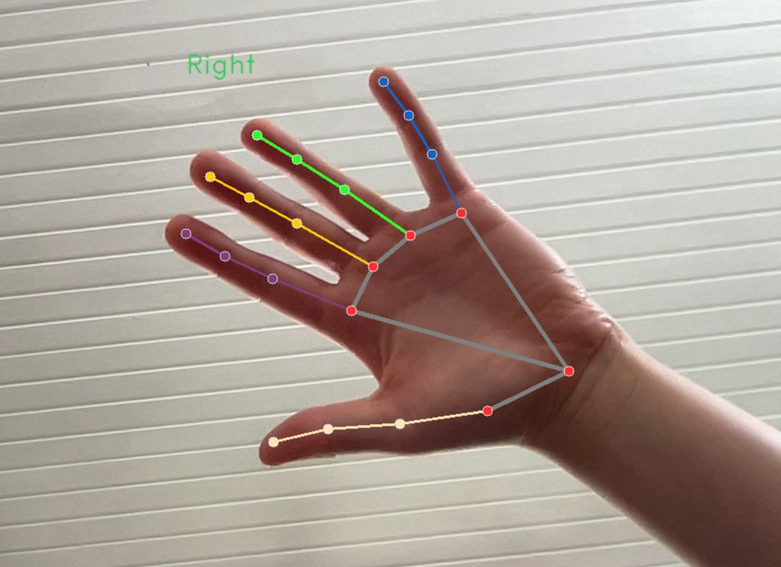
Figure 3.4: Visualization of Hand Landmarks for Gesture Recognition

Button interaction on App
There is also a GUI interface, implemented with Tkinter, for users who prefer mobile or physical input. The app has buttons that are tagged:

      - Previous
      - Next
      - Zoom In
      - Zoom Out

These buttons are connected to Firebase Firestore. When a user clicks a button, a command is written to the database. The desktop application, which is con-tinuously listening to Firestore, detects the change and executes the appropriate action in real-time.
This feature also allows remote users to control the display without needing to be physically in front of it, offering enhanced accessibility and broader interaction options.

UET_CE_Latex_Template/Figures/Code Snippet A.png
Code Snippet A: Firebase command listener and GUI control logic.

Firebase Cloud Communication Architecture
To provide real-time synchronization of the desktop application with the mobile app, the system is integrated with Google Firebase Firestore, a NoSQL cloud database. Firebase architecture is essential in providing instant execution of user commands made through the app to the desktop system.
The Python backend establishes a secure connection to Firestore via a service account key (JSON). After connection, the application subscribes to a given col-lection (e.g., ”data”) and listens for new documents via Firestore’s onsnapshot() listener method. Each document holds a single command like ”NEXT”, ”PREVI-OUS”, ”ZOOM IN”, or ”ZOOM OUT”.
Whenever a new document is written into the firestore collection:

- The onsnapshot() listener fires.
- The system interprets the new command.
- The corresponding media action is performed in the Tkinter GUI.

This architecture maintains the desktop interface synchronized with user inputs from the mobile app in near zero latency, providing improved responsiveness for the system.

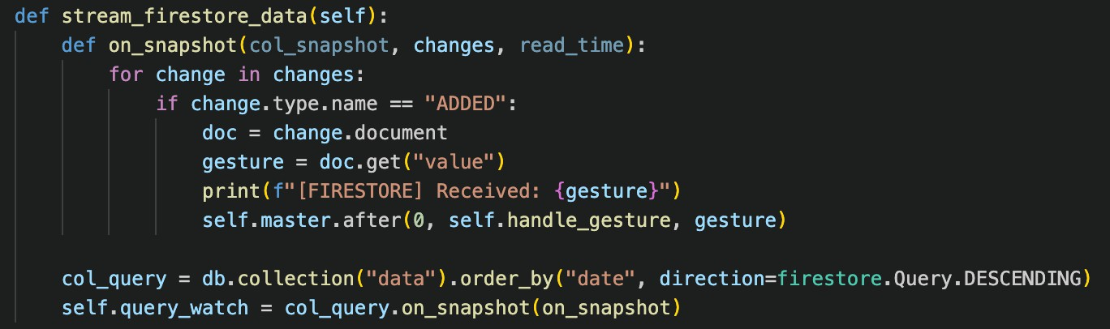
Code Snippet B: Python code implementing the Firestore onsnapshot() listener

This architecture provides smooth synchronization between a mobile app (or any other Firebase client) and the desktop app.

Overview of Real-Time Media Control Sys-tem
The media player loads a video and image files from a local directory, playing them over three frames. When an image is played, it can be zoomed. When video is played, the zoom function is disabled to prevent slowing it down. Real-time hand gesture recognition is performed in a background thread, processing webcam input through MediaPipe. The system determines what gesture is being made on the basis of hand openness, movement speed, and finger distances[2].
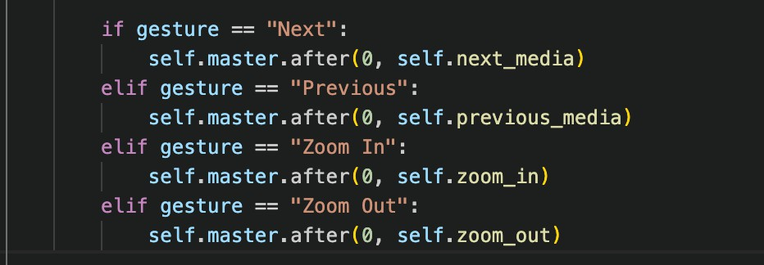
Code Snippet C: Real-time media control logic

Architectural Layers Diagram
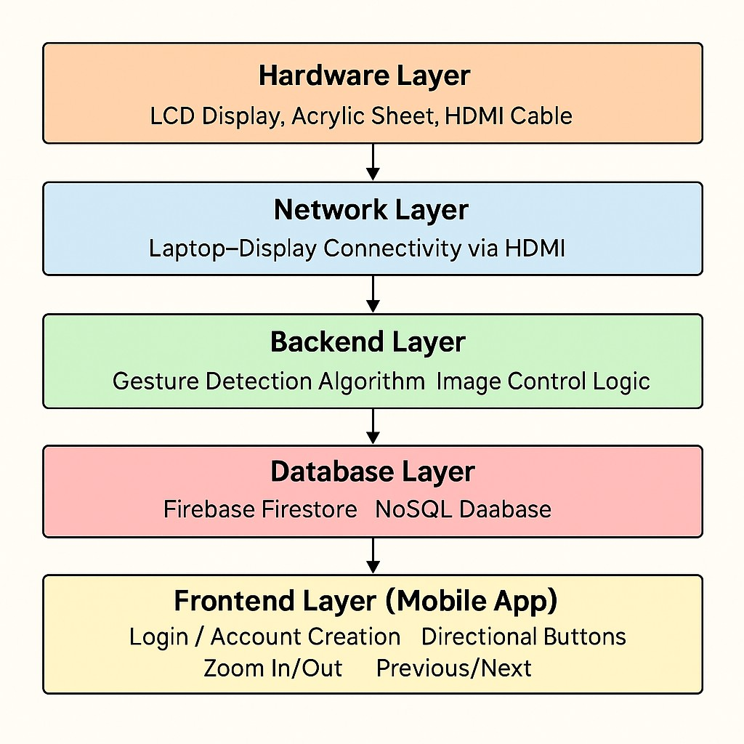
Figure 3.5: Architectural Layers of System

Chapter 4

Hardware and Software Components

The chapter discusses the major hardware and software components that have been used in creating the 3D holographic display system. The hardware and software elements seamlessly integrate with each other to provide precise gesture recognition, synchronized communication, and successful visual output using the Pepper’s Ghost illusion. The following is a descriptive overview of the hardware setup.

Hardware Requirements and Setup
The hardware configuration provides the basis for the overall system, providing gesture input, processing, and 3D visual projection. The structure focuses on mak-ing the system affordable, portable, and easy to build using commonly available parts to construct a working and visually appealing holographic display.

Laptop and Internal Camera
The central computation processing is taken care of by a regular laptop, with which the Python-based gesture recognition and Firebase integration scripts are executed. Real-time video input capture is carried out by the inbuilt webcam, with subsequent processing via MediaPipe for hand gesture detection.
To allow precise landmark tracking, a webcam of high resolution is preferably 720p (HD) or higher to provide clear visualization of finger joints and contours of the hand under diverse lighting conditions. The camera has to be set at the right angle and distance to cover the complete hand-movement in the frame. The central computation processing is taken care of by a regular laptop, with which

19

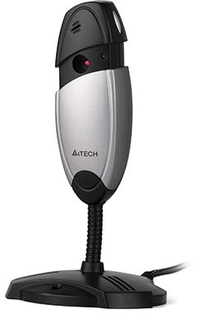

Figure 4.1: Webcam

the Python-based gesture recognition and Firebase integration scripts are exe-cuted. Real-time video input capture is carried out by the inbuilt webcam, with subsequent processing via MediaPipe for hand gesture detection.

Prism Construction and Display Platform
Holographic prism is constructed from clear sheets of acrylic glass. The sheets are precisely cut and spliced together in an angled formation (typically 45 degrees) to form an inverted pyramid structure. This configuration is necessary to generate the Pepper’s Ghost illusion, which displays the LCD images in a way that they are observed to float in 3D within the prism space. For mounting and structural stability, the base of the prism has been supported by a specially constructed wooden platform of screen size for alignment. The wood is trimmed and built to shape a solid framework on which acrylic glass is placed firmly without shaking when in use. This stability is important in order to prevent the reflected image from flickering or changing, which would undermine the quality of the illusion.
The source display is a 19-inch Acer LCD monitor, horizontally mounted near the prism base. The monitor projects specially treated images or video that are reflected off the inclined glass walls of the prism, producing a holographic visual effect. These images are pre-aligned and rendered to take into consideration the angles and transparency of the acrylic material, optimizing the depth and realism of the projected item. For enhancing the quality and contrast of the reflection, the area surrounding the structure is covered with black fabric or black opaque wooden walls. This minimizes ambient light interference and ensures that the focus of the viewer stays on the projected image. Also, the application of materials with light absorption extends contrast by avoiding unnecessary reflections and ensuring optical clarity, particularly in well-lit conditions.

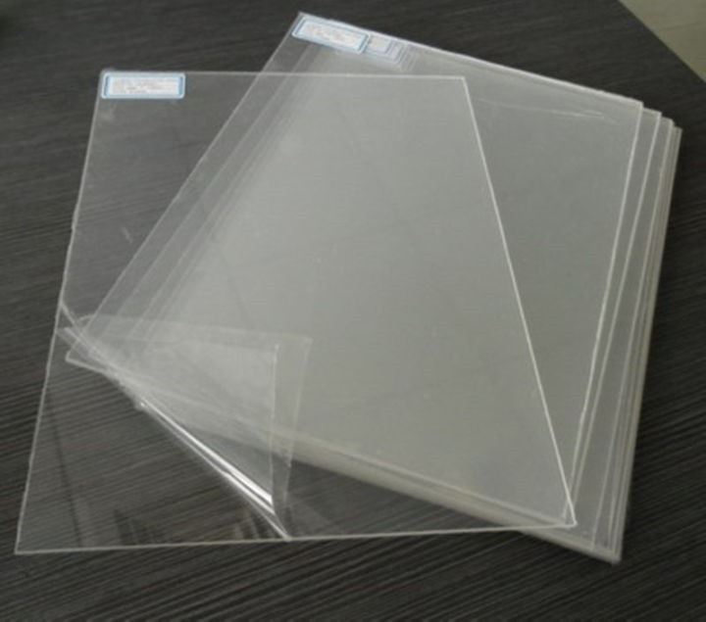
Figure 4.2: Acrylic Sheets
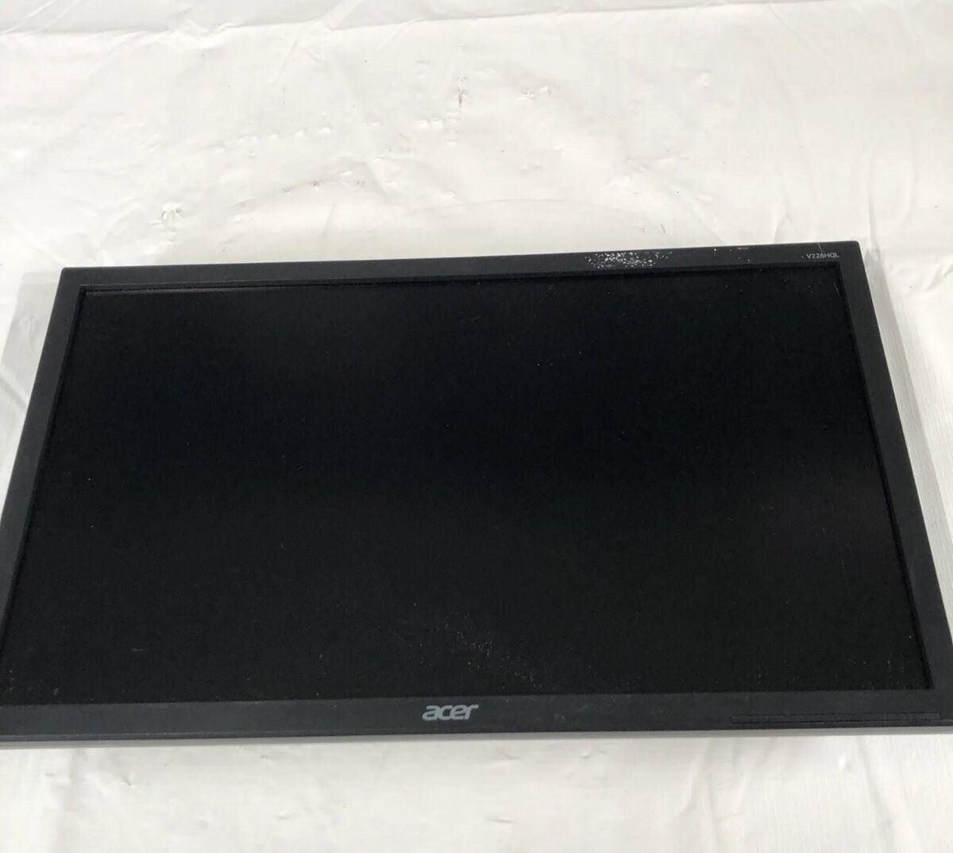
Figure 4.3: LCD

The laptop’s video signal is sent to the external Acer LCD display through an HDMI cable, which provides high-definition digital output with low latency. Such a connection guarantees that the LCD screen shows synchronized content with real-time gesture input and command updates from the mobile application or Firebase
In conclusion, the high-resolution webcam, transparent acrylic glass, wooden sup-port, Acer LCD screen, and HDMI connectivity are combined to provide the phys-ical framework that offers an entirely interactive holographic user experience.

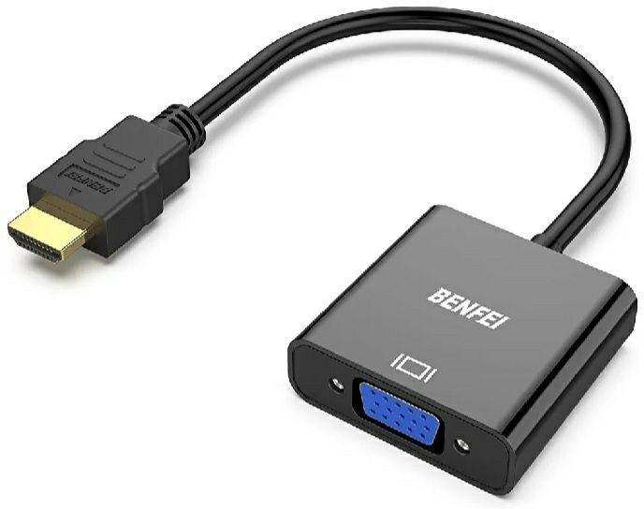

Figure 4.4: HDMI to VGA Converter

Software Stack
The software stack includes a combination of open-source Python libraries and Firebase integration for cloud communication.

Python with MediaPipe and OpenCV
The execution of real-time gesture recognition within this project is ultimately accomplished through the use of two of the most powerful Python libraries: Medi-aPipe and OpenCV. These libraries are at the foundation of the gesture detection system, allowing the holographic display to recognize and react to user hand ges-tures in real time.

      - MediaPipe: Google-developed MediaPipe is a general-purpose framework for constructing cross-platform multimodal applied machine learning pipelines. In this environment, MediaPipe’s hand tracking solution is being used to identify and track the 21 significant landmarks of a human hand. The so-lution offers accurate and fast detection even with changing light conditions and hand orientations, which makes the solution perfectly suitable for ges-ture recognition in an environment that is dynamic in nature.

      - The hand tracking module does two stages: initially, a palm detection model detects the region of interest (i.e., the hand), and then a hand landmark model projects the detected region onto 21 three-dimensional coordinates that correspond to key points on the hand including fingertips, joints, and wrist. These landmarks are then examined to determine gesture patterns, e.g., directional swipes or finger pinches, that are translated to commands like ”zoom in,” ”zoom out,” ”swipe left,” or ”swipe right.”
      - OpenCV: (Open-Source Computer Vision Library), alternatively, is uti-lized for video capture and frame processing. OpenCV exposes access to the webcam stream and continuously captures individual frames from the video stream. These frames are then submitted to MediaPipe for real-time processing. OpenCV also takes care of frame conversions like resizing, color space conversion (e.g., BGR to RGB), and drawing visual annotation like hand skeletons or bounding boxes for debugging and user feedback.

In collaboration, MediaPipe and OpenCV play a joint role in providing a fast and accurate gesture recognition experience. OpenCV takes snapshots of the vi-sual data stream, while MediaPipe handles the input to identify the gestures at high precision. This synergistic play makes the system free from dedicated hard-ware—powered solely by an ordinary webcam and optimized software algorithms.
In addition, the configuration is lightweight and platform-neutral. The Python code can operate on any contemporary operating system without recourse to GPU acceleration, although GPU is an option available for speeding up performance. This renders the gesture recognition module scalable and portable to future im-provements like multi-hand recognition, new gestures, or interfacing with external devices.

Code Snippet D: Use of MediaPipe for hanlding real-time hand gestures

Tkinter and CustomTkinter GUI Design
The system’s graphical user interface (GUI) is essential in the management, pre-sentation, and control of media synchronized with both gesture and mobile app inputs. The GUI is constructed based on CustomTkinter, a refined modernized

version of Python’s default Tkinter library. CustomTkinter offers extra widget styling, theming support, and also layout flexibility, allowing for a neater, more user-friendly interface consistent with contemporary UI/UX principles.

Design Rationale:
Tkinter was selected due to its simplicity, dependability, and strong Python in-tegration. The fundamental Tkinter look can feel stodgy or inflexible, though, especially for a project focusing on futuristic screen technology. CustomTkinter fills this void by providing extensible themes, rounded widget borders, hover ef-fects, integrated dark theme, and resizable layouts, all while remaining compatible with the original.

Tkinter Architecture:
The GUI wasn’t only intended to work but was also intended to reinforce the visual illusion of being holographic. It maintains real-time control of media, man-ages media files, and offers internal coordination between video playing, image rendering, and gesture input. It is also the interface where threading, Firebase sync, and media update meet. Frame Layout and Media Projection.
GUI has three main display frames:

- Frame 1 (Left): Designed to project onto the leftward-facing acrylic side of the prism.
- Frame 2 (Right): Projects the reflected image or video to the right side.
- Frame 3 (Bottom): Displays the upside-down version, designed to reflect upward onto the base of the prism.

GUI Features:
The system’s graphical user interface (GUI) has been optimized to improve usabil-ity as well as visual clarity. It consists of three specialized display frames—Left, Right, and Bottom—that are mapped onto the reflective sides of the holographic prism. They are dynamically refreshed to display media content in real time, with both images and videos being supported effortlessly. For maximum visibility and minimizing distractions, the interface uses a dark motif that offers high con-trast between the content of the media and the background. All user interactions and media updates are also taken care of smoothly using the principal Tkinter event loop, such that the system is always responsive and the user has a smooth experience during the operation of the system.

Every frame is done as a CTkFrame (CustomTkinter frame) and is created with defined dimensions, padding, and background color. They are laid out as a grid or horizontal/vertical split layout depending on window size and screen resolution. Rotated photos or video frames are drawn separately inside every frame using labels or canvases that renew dynamically as new material becomes visible.

Styling and Theming:
CustomTkinter has support for light and dark themes, in addition to custom color schemes. Herein, a dark theme was chosen to improve the legibility of the media display, lower glare, and highlight the holographic effect. All frames have their backgrounds neutral or dark gray to provide high contrast with bright media content. Button appearances are consistent, circular, and are event-driven for hover effects to provide a contemporary feel of interaction. Font styles are the same for all GUI items so as not to disturb aesthetic consistency.
Some of the important visual attributes are

- Proportional resizing: Frames and widgets resize proportionally as win-dow size is varied.
- Rounded corners and shadows: Employed on frames and buttons for a professional-looking effect.
- Centralized media control buttons (if shown locally): These are ”Next”, ”Previous”, ”Zoom In”, and ”Zoom Out”, designed for ease of read-ing and responsiveness.

Media Integration with Frames:
Every display frame is closely coupled with the MediaPlayer class methods like show image() and show video().
When an image is being loaded, it is:

- Rescaled proportionally to the target frame.
- Rotated using OpenCV transformation functionality to match the direction of projection.
- Rendered on a Tkinter-compatible PhotoImage or Canvas widget in each frame.

Frames for videos are recorded and processed separately and posted to every dis-play frame at regular intervals. This method ensures a smooth visual projection on every side of the Pepper’s Ghost prism, generating the desired holographic effect in real time.

Event Handling and Responsiveness:
To make sure the GUI is responsive even when the program has to execute com-putationally intensive tasks such as gesture detection and video frame capture, Tkinter’s event loop (main loop) is combined with the after() function. This func-tion posts periodic updates without intermitting the interface, which is important in:

- Real-time video playback
- Gesture Driven Updates
- Real-time Firebase command execution

Also, GUI state changes driven by background threads (like Firebase listeners or gesture recognition) are always routed through the after() method to provide thread-safe operations. Although the main interaction patterns are mobile-driven and gesture-based, the GUI has been implemented with accessibility.
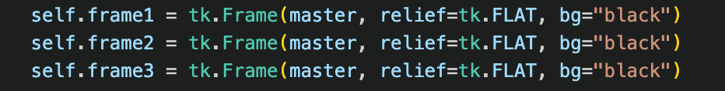
Code Snippet E: Frames Setup for GUI

Command Sync Integration Using Firebase
Firebase Firestore is used in this project to facilitate synchronous transmission of control commands between the gesture recognition module and the mobile app interface. Firestore, Google Firebase’s scalable and real-time cloud database, acts as a common communication platform that guarantees all control inputs—be it hand-gesture initiated or app-based button-pressing—are consistently delivered to the holographic display system with low latency.
The integration process starts by initializing Firebase in the system’s Python-based backend through a service account key. The key, which takes the form of a JSON file, holds credentials and configuration information specific to the Firebase

project. By loading this key, the application identifies itself as a trusted client that can read and write into Firestore. This method provides a secure and easy means of server-side access with no need for user-level login.
After Firebase is initialized, the system sets up real-time Firestore listeners to track certain fields in the database. These listeners are set up to watch for changes in documents that denote user commands. An example is a document field named command that takes values like ”left”, ”right”, ”zoom in”, or ”zoom out” depend-ing on gesture recognition or user input on the mobile app. The moment a value in Firestore is changed due to an action in the mobile application, the listener picks up on the change and calls the respective function within the main control script.
This listener-based design is very effective as opposed to classic polling mecha-nisms. Rather than querying for updates at set intervals, Firestore listeners send data changes in real time, minimizing latency and system load. This provides a guarantee that commands are run near-instantly, allowing the holographic system to have much faster response times and generally providing a better user experi-ence.
To further provide strong command handling, the system involves a timestamp validation mechanism. Every command written to Firestore carries a timestamp that reflects when the action was done. The backend checks the timestamp against the last run command to avoid repetitive execution or conflicts due to repeated signals.
The incorporation of Firebase also supports cross-platform control where users can control the holographic display from any device with internet connectivity. Be it the control input from a hand gesture captured through webcam or a re-mote button click on the mobile app, Firebase ensures command delivery and synchronization.
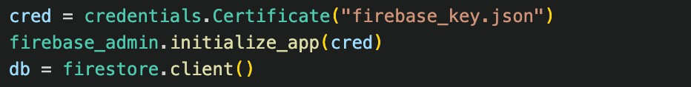
Code Snippet F: Firebase Integration

Mobile App Framework and Control Logic
The mobile app is a key element of the overall 3D holographic media display system architecture providing remote control functionality. Users can remotely send commands to the desktop app through Firebase Firestore using this mobile

interface, allowing wireless and effortless interaction with the holographic display. This part discusses the design, implementation, and operation of the mobile app framework and its control logic.

Mobile App Design and Framework:
The mobile app is made light, intuitive, and responsive in design to be easily operable on a wide range of devices. It usually uses a cross-platform development framework like Flutter, React Native, or an Android/iOS native SDK to cover the largest user base. The app’s interface is a minimalistic set of buttons for media control commands such as ”Next,” ”Previous,” ”Zoom In,” ”Zoom Out.” These controls map one-on-one to the associated command strings that are transmitted to the Firestore database.
The minimalistic design of the app emphasizes user experience, with tactile feed-back and explicit labeling to ensure command activation. The simple interface decreases the learning curve and allows the system to be used by users with dif-ferent levels of technological expertise.

Firebase Firestore integration:
At the center of communication between the desktop application and the mobile app is Firebase Firestore, a cloud-hosted NoSQL database. Firestore is used for its ability to offer real-time synchronization, scalability, and simplicity in integration with several platforms. The app is a client of Firestore that can write command documents into a specific collection ”data.
Every command issued by the app is wrapped in a document with at least these fields:

- value: A string specifying the type of command, like ”NEXT,” ”PREVI-OUS,” ”ZOOM IN,” or ”ZOOM OUT.”
- timestamp: A timestamp generated by the server to ensure command or-dering.
- userid(optional): An ID for the user giving the command, allowing multi-user tracking and possible access control.

When a user presses a control button, the application creates a new command document with the correct ”value” and pushes it to the Firestore ”data” collection. Firestore subsequently takes care of sharing this data, propagating the update immediately to all listening clients, including the desktop app.

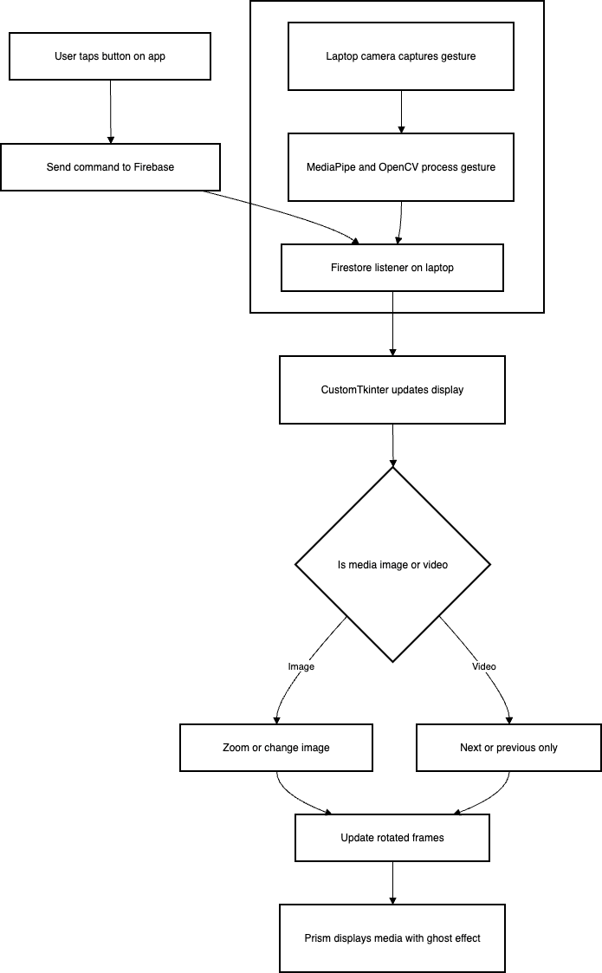

Figure 4.5: Gesture and App-Controlled Media Flowchart

Command Processing and Control Logic:
The desktop program executes a listener that continuously watches for changes in the Firestore ”data” collection. Upon sensing a new command document, the listener picks up the command value and invokes the respective media control function within the local application[1]. Such decoupled communication design makes it possible to maintain a responsive and scalable control system, where the app and desktop parts run asynchronously but are tightly synchronized using Firestore.
It is an architecture that provides near-instant command execution, where the average synchronization latency is in the order of the low hundreds of milliseconds, varying with network conditions. Such responsiveness is necessary for providing a smooth and interactive user experience during playback of interactive holographic media.

Advantages and Importance:
Incorporating a mobile app with Firebase synchronization provides significant value to the overall system design.
Following are the key advantages:

- Remote Accessibility: Users can exercise control over the 3D holographic screen from a remote location, even when not standing close to the system. This supports more flexible user experiences, particularly in contexts like presentations during classes, museum exhibits, or promotional installations. By removing the necessity of gesture recognition in each case, the system is more inclusive of users with mobility limitations or where gestures are not possible.
- Multi-user Support: Due to Firebase Firestore’s cloud-based and real-time features, the system can support multiple users sequentially or con-currently, depending on the structure of the command-handling logic. This feature opens doors to collaborative applications like group learning plat-forms, multi-user game interfaces, and collective control in exhibitions or events. Next-level updates may involve user-specific access levels to further tailor control between participants.
- Extensibility: The Firebase-powered command architecture is scalable and modular by design. Adding new app buttons, gesture commands, or even third-party APIs, cloud-based analytics, or IoT devices such as smart lights

and sensors can be easily done by developers. This flexibility enables the system to transform into an interactive media platform of greater scope beyond the original holographic application.
- Reliability and Security: Firebase provides maximum transparency with little downtime, as it is ideal for live demonstrations and open installations. Data is passed across encrypted channels to ensure that interception or unau-thorized access is minimal. Built-in security rules and user authentication within Firestore offer an additional protection layer, ensuring that only regis-tered users can send control commands or access confidential media content.

Chapter 5

System Implementation

This chapter describes how the components of the system were practically imple-mented. It covers gesture recognition, media display handling, Firebase synchro-nization, and threading for real-time performance.

Gesture Recognition and Algorithms
The interactive control system’s core is based on its gesture recognition function-ality, driven by Google’s MediaPipe Hands framework. This cutting-edge hand-tracking technology provides solid, real-time detection of 21 three-dimensional landmarks for each hand, allowing the system to understand subtle hand and finger gestures with incredible accuracy.

Gesture Definitions and Recognition Logic
The system is programmed to detect four main gestures that determine media playback and interaction on the holographic screen:

    - Next/Previous Navigation Gestures:
These are side swiping motions, characterized by the horizontal movement of the index finger. In particular, a rightward swipe invokes the ’Next’ action, moving to the subsequent image or video in the playlist and a leftward swipe invokes the ’Previous’ action, reverting to the last media file.
Gesture recognition algorithm computes the index fingertip’s velocity vector and displacement distance between frames to detect only intended swipes and not incidental or jittery motion. For instance, the system places minimum distance traveled and minimum speed thresholds before validating a gesture.
    - Zoom In/Out Gestures:
32

These are recognized by the relative distance variations of the thumb and other fingers (mainly the index finger). Closing the motion of fingertips together indicates a ’Zoom Out’ and opening up indicates a ’Zoom In’. To avoid false positives due to incidental hand movement or accidental finger nearness, the system only detects zoom gestures when the hand is basically still, as classified by low total hand speed between frames. This steadiness requirement increases accuracy at the cost of demanding users make pinch gestures slowly and consciously.

Algorithm Implementation:
To ensure seamless, real-time performance, the gesture recognition operates within a special worker thread apart from the primary GUI thread. This design avoids freezing the main application during heavy computations involved in video frame processing and landmark detection.
The process within the recognition thread is as follows:

Frame Capture:
Continually take video frames from the laptop’s onboard webcam (usually at 30 frames per second).

Extraction of Hand Landmarks:
Process every frame with the MediaPipe Hands model to identify 21 land-mark points per hand. These landmarks are normalized coordinates for fingertips, joints, and the wrist.

Gesture Detection Logic:
To be able to detect and interpret hand gestures, the system initially com-putes the exact positions of the fingertips and the distances between different landmarks of the hand. From this spatial information, the system can dis-cern relative motion and conformational changes in the orientation of the hand. Then, the motion vectors of important points—specifically the index fingertip—are calculated in consecutive frames in order to track the direction and velocity of movement.
Through monitoring of these vectors, the system comes to understand the path and consistency of hand movements. Lastly, a threshold-logic mech-anism is used to examine such motion patterns. The logic is then used to assess whether a detected gesture meets pre-defined criteria for certain

actions like a swipe or a pinch. The gesture will only be accepted and inter-preted as the corresponding system command when the motion meets these thresholds.

Gesture Event Triggering:
As soon as a valid gesture is recognized, a matching callback function is posted on the main thread with Tkinter’s thread-safe after call, allowing UI components to be refreshed without any concurrency problem. Such a structure allows for near real-time interaction with very little lag, which is important for involving user experience.

Image Capture and Delivery Performance
Developing the Pepper’s Ghost illusion requires projecting images and videos onto three individual frames at specific angles within the acrylic prism config-uration. The system maintains visual content properly aligned and rotated to ensure smooth reflection.

Image Display Workflow:
During loading, images are resized to match the size of the three display frames, which are optimized to project onto roughly equal areas of the laptop screen.
Each picture incorporated into the system is rotated specifically so that it will face in the proper orientation to the intended display frame, and so when projected onto the corresponding side of the holographic prism, it will be accurate. For the left frame, the picture is rotated 90 degrees clockwise so that when it is mirrored upon the angled acrylic glass, it will be standing upright and facing in the proper orientation to the observer from that angle. For the right frame, the image is turned 90 degrees counterclockwise (i.e., -90 degrees) so that it aligns with viewing on the other side of the prism.
Lastly, for the bottom frame, the image is turned 180 degrees so that it essen-tially becomes upside down, and this is to allow it to reflect upward and appear right-sided as seen through the top face of the prism. These individual changes are crucial in sustaining the illusion of a coherent, floating 3D hologram because incorrect rotation would result in twisted or off-axis projections over the surfaces of the prism.

    - These are achieved using the Python Imaging Library (PIL) for fast, high-quality rotation and resizing of images.

    - The rotated images are then drawn inside the Tkinter GUI interface using the PhotoImage widget so they fit perfectly into the media player UI.

Video Playback Process:
Video processing involves additional requirements for frame-by-frame processing and fluid playback:

    - Videos are read and processed through OpenCV’s VideoCapture capability that permits taking out individual frames from video files.
    - Frames of every video are resized and rotated according to the same trans-formation rules as images to ensure consistent alignment on the holographic prism.
    - Smooth playback is ensured by scheduling frame updates in a regular inter-val using Tkinter’s after method, approximating as closely as possible the original video’s frame rate.
    - The system further manages end-of-video events elegantly by looping or ad-vancing to the next media item automatically, based on user preference.

With this careful media processing pipeline, the system maintains the illusion of a floating 3D image, essential for user participation.

App-Firebase-Python Synchronization Work-flow
To allow remote control of the holographic display, the system is integrated with Firebase Firestore, a real-time cloud-based database service that allows synchro-nization between a mobile application and the desktop app.

Initialization and Setup:
- When starting the system, the application empties the ’data’ collection in Firestore in order to erase any stale or leftover commands, providing a fresh start for new interaction.
- Then, a real-time listener is created on the ’data’ collection subscribing to updates sorted by the timestamp (date field) in descending order so that the latest command can be prioritized.

Command Handling Pipeline:
  - When a new command (e.g., ’NEXT’, ’ZOOM IN’) comes from the mobile app, it inserts a new document into the ’data’ collection with a value field holding the command string and a timestamp.
  - The Firestore listener in the desktop client senses the new document and causes a callback function to be called.
  - The callback reads the command and calls a corresponding function in the media player (e.g., next media for ’NEXT’).
  - For thread safety and avoiding GUI freezing, the execution of the command is scheduled via Tkinter’s after method so that updates are on the main thread.

Benefits of Firebase Integration:
  - Real-time Synchronization: Commands are relayed nearly in real-time from desktop to mobile.
  - Cross-Platform Compatibility: Mobile app, created with MIT App In-ventor, interacts perfectly with Python desktop app.
  - Scalability: Firestore cloud-based infrastructure offers support for multiple devices and users without any setup.

This system offers a scalable and robust solution to extend the usability of the system beyond local gesture handling.

Media Player Class Architecture
At the heart of the application’s structure is the MediaPlayer class, which wraps all the functionality pertaining to media display, user interface, gesture detection, and Firebase synchronization.

Key Features and Responsibilities:
    - Initialization: The process starts with the initialization of the Tkinter-based graphical user interface (GUI), wherein individual frames are estab-lished and designed for the left, right, and bottom display areas of the holo-graphic prism. Each one of these frames is carefully placed and sized in order to match the corresponding side of the prism so that accurate and smooth

projection occurs. With this initialization, the program then goes ahead to load all media resources, both images and videos, from a specified directory. This guarantees that the GUI is well stocked with content waiting to be rendered in real-time according to user commands or gesture input.
After the media has been loaded, the system initiates a specialized gesture recognition thread, which runs asynchronously to manage webcam input without disrupting the main GUI loop. This thread persistently examines hand movements in real time through in-built computer vision methods. The app also establishes a Firebase Firestore listener to listen actively for change and commands from the mobile app. This synchronization aspect enables users to control playback of media or switch content remotely using smart-phones, with a seamless multi-modal control interface between the mobile phone, GUI, and holographic display.
    - Media Handling: The system employs a collection of well-documented media handling functions to control image and video presentation throughout the holographic interface. The load media files function searches the media directory, constructs a sorted list of media files, and categorizes them as images or videos. The load current media function then inspects the type of the current file and invokes either show image or show video as appropriate.
The show image method shows the image on all three of the GUI frames, performing required rotation and scaling for each to fit the prism projec-tion. In contrast, show video provides real-time video display by extracting frames, resizing, rotating, and displaying them in a smooth manner for each frame, maintaining synchronized and uninterrupted visual output.
    - User Interaction: The ‘next media‘ and ‘previous media‘ routines handle navigating through the media items by modifying the current media in-dex and rearranging the display accordingly. Conversely, the ‘zoom in‘ and ‘zoom out‘ routines adjust the zoom level of the currently displayed image to keep the scaling within predetermined safe limits to avoid distortion. An important feature is the disallowance of zoom operation when playing back video to protect the integrity and crispness of the video display.
This object-oriented, modular design encourages extensibility and maintainability.

Zoom and Navigation Gesture Functions:
The system’s gesture-based user interface provides natural, intuitive control of media navigation and zooming.

Navigation Functions:
    - The next media function increments the media index in wrap-around through the playlist and calls load current media to update the display.
    - previous media corresponds to decrementing the index with wrap-around to enable smooth navigation.

These functions are attached to swipe gestures and mobile app commands.

Zooming Functions:
    - zoom in increases the zoom level by a predefined step, capped at a maximum zoom factor to preserve image quality and prevent display issues.
    - zoom out decreases the zoom level down to a minimum baseline (no zoom).
    - Each zoom adjustment triggers a refresh of the displayed image to reflect the new scale.
    - Zooming is disabled during video playback to maintain visual integrity, avoiding artifacts caused by scaling dynamic video frames.

The zoom functions enhance the user’s ability to inspect details of images inter-actively within the holographic environment.

Threading and Real-Time Gesture Feedback
Responsive UI design necessitates separating compute-heavy gesture recognition from the main GUI thread.

    - The hand gesture recognition function runs in a dedicated daemon thread, continuously capturing webcam frames and processing them for hand land-marks and gesture detection.
    - After detecting a gesture, the thread communicates safely with the main GUI thread using Tkinter’s after method to queue UI updates, like media navigation or zooming.
    - The threading model avoids the GUI freezing or becoming unresponsive, even for intensive gesture processing.
    - Running a daemon thread guarantees that gesture recognition will exit cleanly when the application is terminated.

Through decoupling input processing and GUI updates, the system has smooth and fluid interactivity.

Error Handling and System Robustness
Correct operation is essential, particularly in an interactive system geared towards diverse environments wherein network stability, lighting levels, and hardware per-formance vary. To make the system operate reliably and deal with unexpected situations well, various strategies have been put in place for error handling and overall robustness.

Error Handling Strategies:
    - Firebase Firestore Integration: All Firebase Firestore interactions (e.g., reading commands or writing responses) are wrapped in try-except blocks. These blocks catch and log exceptions that occur through network timeouts, invalid service credentials, API rate limits, or Firestore permission errors.
For instance, when the system is unable to fetch a command because of tem-porary internet connectivity loss, it does not crash. Rather, it logs an error and waits for the subsequent polling cycle or listener event. This guarantees uninterrupted operation and enables the system to recover automatically when connectivity is re-established.
    - Gesture Detection Stability: Because the gesture detection module uses live webcam input and MediaPipe hand landmark detection, it is suscepti-ble to environmental conditions like lighting, ambient noise, or quick user motion. To improve reliability and reduce false positives or lost gestures, a confidence threshold is used to eliminate doubtful detections. Frame skip-ping is also added to implement short recovery windows when detection is temporarily lost.
In addition, all the image processing operations, such as frame grabbing and hand landmark parsing, are enclosed in error-processing routines to keep the system from crashing because of corrupted or lost frames.
    - GUI and Display Handling: The CustomTkinter/Tkinter GUI is guarded against improper UI state changes. Button presses are debounced, and dis-play frames are only updated if proper media is loaded. If a wrong file path or a corrupted image/video is detected, a suitable error message is displayed, and the system bypasses the faulty media.

    - Logging and Monitoring: A centralized logging system logs errors, warn-ings, and critical system state to a local log file. This assists with runtime diagnostics and is particularly valuable in field testing or demonstrations.

System Robustness Measures:
    - Modular Architecture: The software is modularly designed, such that failure in a module (e.g., Firebase listener or gesture recognition) does not bring the entire system to a standstill. Autonomous modules can keep run-ning and resume their task once the problem is fixed.
    - Real-time Feedback: The system has status indicators (e.g., console logs and app notifications) to verify successful operations such as gesture recog-nition or command receipt so that the user can instantly recognize and react to any anomalies.
    - Graceful Degradation: If gesture recognition does become unstable (e.g., in low light), users can revert to the mobile app controls, which remain operational through Firebase. This dual-mode strategy ensures that the screen remains usable even when one mode of interaction fails temporarily.

Chapter 6

Testing and Evaluation

This chapter presents the testing procedures and evaluation results for the 3D holographic display system. It focuses on gesture detection accuracy, system re-sponsiveness, media playback quality, and Firebase synchronization performance.

Gesture Detection Accuracy
Reliable gesture detection is essential to the usability and functionality of the interactive holographic display system. To determine this, rigorous testing was done with several users executing pre-defined gestures in different environmental setups. The aim was to measure how accurately the system is able to understand user intent from hand gestures.

Testing Methodology:
The testing included five users with varying hand attributes, such as size, shape, and color, to test the model’s reliability on a representative population of users. The gestures used for testing were:

    - Next Gesture(Swipe Right)
    - Previous Gesture (Swipe Left)
    - Zoom In Gesture (Pinch fingers apart)
    - Zoom out Gesture (Pinch fingers together)

Each actor repeated each gesture numerous times—at least 20 repetitions for each gesture—to yield statistically significant data. The tests were performed under three lighting levels:
41

    - Floodlight indoor illumination (∼500 lux)
    - Fairly Bright indoor lighting (∼200 lux)
    - Low light (<100 lux)

The background setting was kept neutral and clean to reduce visual distraction.

Results and Analysis
    - Previous Gestures: The swipe gestures provided a detection accuracy of around 92% among all the participants and illumination conditions. The dynamic characteristic and clear directional motion of the gestures probably attributed to the high rate of recognition. The tracking algorithm of the system successfully distinguished between left and right swipes through the examination of the hand movement trajectory and velocity.
    - Zoom In/Out Gestures: Pinch zoom gestures had a marginally lower detection rate of 88%. The accuracy required to identify fine movements of the finger tip for pinch in and out makes the gesture more demanding. Maintaining firm hand positioning throughout the gesture was important, and natural hand tremors or minor unsteady movements by a few users resulted in periodic misclassifications or lost gestures

The performance difference between pinch and swipe gestures indicates one crucial area for possible system enhancement — increasing finger tip tracking stability, possibly through sensor fusion or more effective filtering algorithms.

User Feedback
Users indicated pinch gestures involved more focus and slow movement, which might impede smooth interaction during real-time use. Other users preferred swipe gestures as being more intuitive and natural, which is consistent with the reported increased accuracy and reduced latency for these gestures[13].

Response Time for Commands (Gesture vs App)
Feedback responsiveness is necessary to ensure smooth interaction between the user and the system. The responsiveness of the system was measured quantita-tively by determining the delay between user input and update in media display.

Measurement Setup:
    - The response time for gesture commands was measured as the duration from the beginning of the detected hand movement and the change in the Tkinter media display frames.
    - For app commands, response time encompassed the network transmission la-tency to Firebase Firestore, cloud processing, and desktop application polling and rendering the command.
50 iterations per test were conducted to achieve average and variance statis-tics.

Result
    - Gesture Commands: Had an average response time of 150 milliseconds. This minimal latency is due to the local, direct processing of video frames on the laptop, which limits overhead.
    - Firebase App Commands: Demonstrated an average response time of 300 milliseconds. Although this is about double the latency of gesture com-mands, it is still within tolerable parameters for real-time interaction con-sidering the inherent network communication.
    - Discussion: The lower latency of the local gesture control mode supports highly interactive use cases where instantaneous feedback is paramount. The mobile app’s cloud-mediated control, on the other hand, offers flexibility and accessibility but with slightly higher response times.

Additional latency savings on app commands may be explored by streamlining network usage or taking advantage of edge computing technologies.

Media Playback Smoothness
The fundamental functional specification of the system is the smooth and reliable playback of multimedia materials, such as images and videos, on the three screen frames making up the Pepper’s Ghost illusion.

Testing Procedure
Media play module was tested by loading a handpicked collection of images and videos of different resolutions and types. Playback functionality was tested for:

    - Image consistency in correct display with rotation and scaling on all three frames
    - Video smoothness in terms of frame rate consistency and lack of visual glitches.
    - Smooth transition when changing between various media files.

Tests were conducted multiple times to gauge stability after prolonged use.

Observations
    - Image Display: All test images were displayed uniformly with exact rota-tion (90°, - 90°, 180°) performed on corresponding frames. No misalignments or cropping problems were identified, which validates the stability of the PIL-based rotation and scaling code.
    - Video Playback: Video played fluently at their original frame rates without noticeable frame drops or stuttering, even for longer videos (up to 5 min-utes). Smooth playback was essential to maintain the seamless holographic experience.
    - Media Transition: Media file switching was smooth without flickering or latency, ensuring continuous interaction. Such smoothness was especially crucial when switching between images and video in a demo environment.

Synchronization Latency with Firebase
Real-time synchronization of the mobile app and desktop application is critical for remote control functionality[5].

Testing Method:
Latency was assessed by logging timestamps on command dispatch in the mobile app and command receipt and execution in the desktop application. Tests were executed over average home Wi-Fi networks with average upload/download rates of about 20 Mbps.

Results:
    - The average command propagation time was about 300 milliseconds.
    - This latency did not significantly compromise the user experience in most use cases, facilitating responsive remote control.

Considerations:
    - Although 300 ms is tolerable, network instability at times resulted in spikes of up to 600 ms, demonstrating the impact of internet stability.
    - Techniques that could combat these spikes include local command caching or anticipatory command execution algorithms.

Limitations in Detection and Media Control
Although the system performed robustly, certain intrinsic and implementation-dependent limitations were found:

Limitations Gesture Detection:
    - Low-light conditions reduced the accuracy of the system, as is common with computer vision problems where camera sensors fail to identify subtle finger details.
    - Hand distances over 1 meter created downsized hand images, lowering land-mark detection accuracy.
    - Occlusions, like fingers on top of each other or partial exposure of the hand, sometimes led to misdetections.

Media Control Constraints:
    - To ensure video playback quality and prevent visual corruption, zoom func-tions were disabled during video playback. Such limitation decreases user interaction flexibility but ensures content integrity.
    - The system does not support multi-gesture commands simultaneously, thus limiting more complex control methods such as combined zoom and rotate.

Firebase Dependency
    - Mobile application and desktop synchronization rely on perpetual internet access. In offline or weak network conditions, remote control is lost, decreas-ing system flexibility.
    - Furthermore, dependence on third-party cloud services presents probable privacy issues and necessitates secure means of authentication.

Summary and Implications:

System Efficacy and Usability:
The comprehensive testing and evaluation phase confirmed the system’s effective-ness in providing intuitive and reliable control over the 3D holographic display. The dual-mode control scheme, combining gesture input and mobile app commands, offers users flexibility to interact in a manner best suited to their preferences and environmental context.

Gesture Recognition Performance:
Swipe gestures demonstrated high accuracy and low latency, enabling smooth navigation through images and videos. Pinch gestures for zoom, while slightly less consistent, remain functional and essential for interaction, highlighting an area with room for improvement.

Media Playback and Illusion Integrity:
Playback across the three rotated frames remained consistent and well synchro-nized, preserving the immersive Pepper’s Ghost illusion. This synchronization is vital for maintaining the convincing 3D visual effect that is central to the system.

Future Improvement areas:
- Zoom Gesture Robustness: Incorporating sensor fusion or depth cameras to improve accuracy and reliability.
- Expanded Media Controls: Adding support for video zooming and rota-tion to enrich interactivity
- Offline and Alternative Communication: Developing offline modes or local communication protocols to reduce dependency on cloud services and improve system resilience.

Potential Applications:
The system shows promise for practical deployment across various fields including education (interactive visual aids), marketing (captivating displays), and assistive technologies (touchless control for enhanced accessibility).

Chapter 7

Results and Discussion

Gesture Recognition Performance Analysis
The essence of the interactive 3D holographic display system is real-time accurate interpretation of the user’s hand gestures. To this effect, the MediaPipe Hands framework was used, guaranteeing stable tracking of 21 essential hand landmarks per frame. The high-granularity landmark tracking supports recognition of a wide range of complex hand gestures based on spatial relations and motion dynamics.

Test Setup and Methodology:
For systematic assessment of the performance of the gesture recognition module, an extended testing procedure was defined. The system was tested using a range of controlled and semi-controlled environments, with a focus on factors that are likely to influence computer vision-based hand tracking:

    - Hardware and Environment: Testing was conducted with a standard laptop that had a built-in HD webcam which recorded at 30 frames per second. The environment was an indoor laboratory room with noistriless backgrounds to reduce visual noise.
    - User Diversity: Five users were used to capture inter-user variability, and these users varied in hand shape, size, skin color, and natural gesture tempo, aiding in evaluating the model’s generalizability.
    - Operational Parameters: Predefined gestures were performed by users at distances varying from 0.5 to 1 meter from the camera, with natural hand orientation and speed variation.

Recognized gestures in the set were:
47

    - Swipe Left (as ”Previous” command)
    - Swipe Right (as ”Next” command)
    - Zoom In (move fingers apart for pinch)
    - Zoom Out (move fingers together for pinch)

These gestures were chosen based on their intuitive correspondence to typical media controls and recognition feasibility.

Performance Metrics and Observations:
The assessment emphasized major parameters like accuracy of detection (percent-age of correct gestures identified), latency (delay between gesture completion and system reaction), and false-positive rates (cases of incorrect gesture detection).

    - Swipe Gestures: Swipe Left and Swipe Right commands had high accu-racy, with an average of over 90% for all users and illumination conditions. The comparatively big and fast horizontal movement of the hand helped to clearly differentiate these gestures, minimizing misclassification. Latency in swipe detection was negligible, usually below 150 milliseconds, allowing smooth user experience.
    - Zoom Gestures: Pinch zoom in and zoom out were harder to detect re-liably. Accuracy averaged 75–80%, with performance highly dependent on lighting conditions and visibility of hands. Low light and partial occlusions diminished the system’s capability to track finger tips accurately and result in missed detections. Zoom gestures also incurred a bit more latency because extra processing is involved in computing finger distances.
    - Robustness and Noise Filtering: Perhaps the most important improve-ment was the implementation of hand-open detection and velocity thresh-olding to remove involuntary or ambiguous movements. This filtering had a dramatic effect in eliminating false positives due to random hand movement or resting positions, thus enhancing overall system reliability.

User Interaction Mode Evaluation
There were two concurrent modes of user interaction built into the system, each with its own advantages and drawbacks:

- Local Interaction: Gesture-based Input: Users interact directly with the holographic screen through hand gestures detected by the laptop camera.
- Remote Interaction: Mobile App Input: Users give commands using a mobile app, which talks to the system utilizing Firebase Firestore as a real-time cloud-based database.

Comparative Analysis:

Aspect | Gesture-based Input | Mobile App Input
Latency | Low latency (¡200 ms) for di-rect gestures | Slightly higher latency ( 300 ms) due to cloud communica-  tion
Usability | Natural, intuitive but requires  user presence in front of the camera | Convenient for remote control, no proximity requirement
Accessibility | May pose challenges for users with limited hand mobility or  in poor lighting | Accessible for a wider range of users, including those unable  to perform gestures
Flexibility | Limited to physical line-of-  sight and camera field of view | Can operate from anywhere  with internet access
Technical Com-  plexity | Requires robust gesture detec-  tion and calibration | Depends on stable internet and  cloud sync

The two-mode interaction scheme offers robustness in that fallback control through the mobile app is possible if gesture recognition cannot be used or is impractical. This redundancy enhances overall system usability and renders it suitable for a range of usage scenarios — from hands-free instructional demonstrations to remote presentations.
Feedback from users gathered during trials was in favor of gesture control for active demonstration scenarios, attributing the experience of direct interaction as engaging and immersive. On the other hand, the mobile app was preferred when it came to access and convenience, particularly in a group situation or for people less comfortable with the precision of gestures.

Pepper’s Ghost Display Effectiveness
Pepper’s Ghost illusion constitutes the visual center of the 3D holographic display system. It employs optical reflection principles to generate a convincing appear-ance of floating, three-dimensional images within a transparent pyramid prism made of acrylic sheets.

Setup and Rendering Technique

    - The system displays images and video content concurrently on three screen frames at the bottom of the pyramid.
    - The content of each frame is rotated by particular angles (90°, -90°, and 180°) through the Python Imaging Library (PIL) to align reflections properly on the three transparent faces of the prism.
    - The frames are rendered with Tkinter to maintain synchronization and real-time update of visual content.

Visual Perception and User Experience

    - Depth Perception: User experiences verified that the pyramid structure effectively created a deep feeling of illusion. The mirrored images seemed to float within the center of the prism, generating a three-dimensional feel-ing. Slight movements by users from the edge of the display maintained the illusion, establishing a sense of spatial presence.
    - Clarity and Brightness: Best display quality was realized under dim to moderate ambient conditions. Too much ambient light watered down the illusion by lowering contrast and creating unwanted reflections on the acrylic surfaces. The laptop screen brightness levels were all-important, needing maximum brightness settings in order to produce vivid projections.
    - Alignment and Calibration of Frames: Geometric calibration of the Tkinter frames had to be accurate. Ghosting or double images resulted from small misalignments of a few pixels, making the illusion less effective. Custom rotation and scaling algorithms were used for dynamically adjusting content alignment to the required level.

Advantages of the Pepper’s Ghost Setup

    - The method is inexpensive, utilizing cheap materials and consumer hardware instead of commercial volumetric displays.

    - Modular architecture provides easy modification for different screen sizes and aspect ratios.
    - Interactive control via gestures and remote app inputs serves to enhance visual enjoyment with touchless, intuitive interaction.

Limitations and Considerations

    - Illusion demands users to look at the screen from particular angles — prefer-ably above and in the middle in front of the prism. Off-angle viewing dimin-ishes the 3D effect and produces visual artifacts.
    - There is some loss of brightness from inefficiencies of reflection, reducing the display’s effectiveness in well-lit rooms.
    - The hologram is essentially a 2D projection that’s recreated in 3D space, which constrains the system from expressing true volumetric or dynamic depth cues.

Advantages and Disadvantages of Utilizing Firebase
Firebase Firestore was chosen as the cloud database for synchronizing remote control commands from the mobile app to the laptop system. Its integration was beneficial but had its challenges.

Benefits

    - Real-time Updates: Firebase’s low-latency data synchronization provided command updates to be reflected on the holographic display in roughly 300 milliseconds. This near-immediate feedback was key to keeping a responsive user interface.
    - Interoperability across platforms: Firebase effortlessly connected the mobile application (created using MIT App Inventor) and the Python desk-top app, showcasing great compatibility across various development environ-ments and programming languages.
    - Scalability: The cloud-based architecture ensures multi-device connections at the same time without compromise, providing scope for future system revisions with potential multi-user control features.

    - Ease of Setup: Firebase’s vast documentation and SDKs made imple-mentation easy. Python Firebase Admin SDK enabled easy authentication, database reads/writes, and listener event handling.

Challenges

    - Network Dependency: The system’s dependence on Firebase requires stable internet connections, which could be a limiting factor in remote or bandwidth-restricted environments.
    - Conflict and Concurrency Resolution: Managing concurrent commands from various devices is crucial so that race conditions or command overwrites are avoided. Simple last-write-wins logic in the current prototype may not be effective in collaborative situations.
    - Security and Privacy: Security issues arise with cloud communication, necessitating strong authentication, data encryption, and access control to safeguard user commands and prevent unauthorized control.

General Discussion
This project showcases the viability and advantages of marrying computer vision-based gesture recognition with cloud-synchronized mobile control into an interac-tive 3D holographic display platform. The marriage between hardware-efficient Pepper’s Ghost illusion and open-source software frameworks offers an accessible yet influential user experience.
Possible application fields are:

    - Education: Interactive 3D models of biology, chemistry, physics, or engi-neering can aid conceptual insight through enabling natural navigation and manipulation of virtual content.
    - Marketing: Contactless product exhibits facilitate interactive 360-degree images and immersive ads that engage customer interest without contact.
    - Exhibitions: Museums and galleries can utilize engaging holographic guides or artifact displays that react to visitor gestures or remote commands.
    - Assistive Technologies: Hands-free operation advantages people with mo-tor disability or restricted mobility, encouraging inclusive access to digital content.

Though the existing system has been able to achieve encouraging results, there is sufficient potential for future enhancement — especially gesture detection robust-ness, more interaction modalities, and realism of the hologram. The two-input ap-proach guarantees usability in a wide range of environments and user requirements, opening doors for even more adaptive and interactive holographic experiences.

Chapter 8

Future Work and Enhancements

Technical Constraints and Challenges Encoun-tered
Although a working 3D holographic display system coupled with gesture con-trol and Firebase-supported mobile application interaction was successfully imple-mented, various technical constraints and challenges were realized during devel-opment and testing. The limitations are crucial in determining areas to improve and enhance in the future.

Gesture Recognition Accuracy
The MediaPipe hand gesture recognition system is a foundation of this project, facilitating intuitive and touchless control. Its performance, though, is beholden to a range of environmental and hardware influences that impact precision and reliability. For instance, lighting plays a significant role; intense backlighting or low ambient illumination can make it difficult for the camera to accurately detect hand landmarks. Likewise, busy or heavy backgrounds inject noise, occasionally leading to skipped or spurious gesture detection.
Subtlety of finger motion is another limitation. Gross hand motion such as swipes is consistently detected while finer motions like pinch-to-zoom or finger curls tend to be misclassified. This is again because finger poses are difficult to interpret from a 2D webcam stream due to the challenges of occlusion and depth. Addi-tionally, the current system employs static threshold values of velocity, distance, and landmark angles to differentiate gestures. Although tuned in development, these thresholds do not accommodate individual variation across different hand sizes, movement speeds, or gesture styles. The result is that gesture accuracy
54

varies greatly across users[3].

Camera Dependency
The system is intended to work with a typical laptop webcam, which has range and field-of-view constraints. In contrast to depth cameras or infrared sensors, typical webcams can only record 2D color images without spatial depth data. This constraint prevents the accurate measurement of hand position and orientation in three-dimensional space. Furthermore, the fixed field of view implies that users need to have their hands in a fairly narrow and illuminated region in order for detection to function reliably. Movement beyond this region leads to lost tracking and disrupted control.
In addition, webcams tend to have low resolution and frame rate, limiting the fidelity and responsiveness of the gesture system. This is in contrast to dedicated hardware utilized in commercial gesture recognition applications, which utilize multi-camera arrays or depth sensing to achieve higher accuracy.

Limited Command Set
Current system supports a minimal command set including four primary gestures: swipe left, swipe right, zoom in, and zoom out. Although adequate to illustrate core functionality, this minimal set limits the degree of interaction. Video control is also minimal, supporting only next and previous navigation with no pause, play, fast-forward, rewind, or seeking capabilities.
This minimalism is also a result of the difficulties in reliably separating more com-plicated gestures with the existing recognition technique. Adding extra commands would necessitate an enhanced classification scheme and possibly further training data to ensure usability and minimize user frustration.

Single-user Control
The architecture at present supposes one user only will be dealing with the sys-tem simultaneously. It doesn’t distinguish between various users who can try to manipulate the display at the same time. Additionally, the system won’t respect inputs in cases where gesture commands overlap with Firebase app commands. This might make the system behave randomly or not as expected in multi-user or public application environments.
Without identification of the users, concurrent inputs cannot be handled or control rights delegated. This restriction diminishes the level of collaborative use scenarios like group work in a classroom or interactive exhibitions.

AR Preview and Feedback
One of the major usability limitations is the absence of visual preview or aug-mented reality overlay to enable users to validate commands prior to their exe-cution. In the absence of instant feedback, users will resort to trial-and-error to accomplish intended interactions, which is frustrating and time-consuming.
For instance, during the zoom gesture, neither the level of zoom nor a preview of the new size of the hologram is provided. This absence of visual feedback diminishes user trust and restricts the intuitiveness of the system, particularly for new or occasional users.

Proposed Enhancements
To solve the identified issues and bring out the maximum potential of the system, some future upgrades are suggested. These upgrades are based on the existing framework and are intended to make the holographic display system more accurate, interactive, accessible, and scalable.

Gesture Classification Using Deep Learning
Beyond heuristic thresholding, advancing the gesture recognition module using deep learning methods can potentially enhance accuracy and generalizability. Deep models like Convolutional Neural Networks (CNNs) or Recurrent Neural Networks (RNNs) are capable of learning intricate spatial and temporal patterns directly from raw data, allowing them to classify gestures more reliably under varying conditions.

Proposed Implementation:

      - Gather a diverse dataset of labeled hand gestures across multiple users, light-ing setups, and hand positions through MediaPipe landmarks.
      - Implement and train a low-weight CNN or RNN model optimized for low-latency inference. This model would process sequences of hand landmark coordinates to recognize gesture classes.
      - Implement frameworks such as TensorFlow Lite or ONNX Runtime to imple-ment the model within the Python environment to achieve real-time gesture recognition using standard hardware.

Benefits:

      - Higher gesture detection accuracy and variability resistance to changes in illumination, background, and user variation.
      - Optimization for recognizing a greater and more diversified set of gestures, including thumbs up, pause, rotation, or multi-finger swipes.
      - Ongoing refinement by retraining the model with new data, enabling adap-tation to new gestures or populations of users.
Making deep learning also opens the door to dynamic gesture adaptation, as users are able to train the system with new commands tailored to their needs or desires.

Voice Command Support
Implementing speech recognition functionality can offer a complementary and al-ternative input modality, significantly improving convenience and accessibility. This is especially useful in situations where gesture recognition is challenging or unfeasible, like in low light, users holding something, or users with restricted hand mobility.

Proposed Tools and Approach:

      - Add Python’s speechrecognition library or the Google Assistant SDK to handle voice inputs.
      - Establish a controlled voice command vocabulary coordinated with the cur-rent gesture commands, such as: “Zoom In,” “Next,” “Rotate,” “Pause,” and “Play.”
      - Use fallback and fallback logic to alternate between gesture, voice, and Fire-base inputs depending on availability and context.

Advantages:

      - Multimodal interaction enables users to easily alternate between voice and gesture control for maximum convenience.
      - Hands-free operation accommodates users with disabilities or those involved in activities where their hands are busy.
      - Integration with smart speakers, headsets, or wearable microphones broadens deployment scenarios, including classrooms and professional presentations.
Voice commands would complement gesture inputs and could be especially useful in noisy environments where voice recognition accuracy may vary.

Mobile App with AR Preview
The existing mobile app acts mostly as a remote control issuing basic commands to the Firebase backend. This process can be significantly enhanced by incorporating Augmented Reality (AR) functionality that offers users a hologram preview, first before it is projected, allowing for precise control of positioning, scale, and rotation.

Proposed Enhancement:

      - Reimplement the mobile app using platforms like Unity integrated with Vu-foria SDK or ARCore/ARKit for AR functionality.
      - Develop a feature that projects a 3D holographic model overlay onto the camera view of the phone, replicating the manner in which it will appear on the Pepper’s Ghost prism.
      - Enable users to adjust the model with intuitive touch motions such as pinch-to-zoom, rotate, and drag, making adjustments in placement and size before issuing commands.
      - Sync final tweaks to Firebase for instantaneous updates to display.

Advantages:

      - Improved control accuracy and enhanced user certainty through enabling users to see adjustments before display.
      - Increased educational value, since students can learn about and manipulate holograms from within their space, improving comprehension.
      - Fosters experimentation and tailoring, raising motivation and satisfaction.
      - AR previews will render the system more responsive and aware, and be an effective tool for demonstrations and professional applications.

Multi-user Interaction Support
In real-world use cases like classrooms, exhibitions, or collaborative spaces, it is essential to support multiple concurrent or sequential users. Supporting multi-user interaction ensures the system becomes scalable and group-conducive.

Recommended Features:

      - Implement mechanisms for identifying users, such as facial recognition through the camera or authenticated mobile app login, to identify individuals.

      - Create a queue or session management system in Firebase to manage and sequence user inputs so that there is no command conflict.
      - Implement lock tokens or control priorities to provide exclusive control over active sessions for seamless user experience. Include an interaction history log to capture commands and user action for analytics and enhancement.

Advantages:

      - Enables collaborative learning scenarios within classrooms where students can take turns, engage, and learn through shared manipulation of holo-grams, encouraging engagement, collaboration, and better comprehension of intricate subjects through shared visuals.
      - Eliminates command conflicts and disorder in public areas or exhibition envi-ronments through efficient handling of concurrent user inputs. This ensures that multiple users can interact with the system in a orderly manner without conflicting commands or interference.
      - Facilitates data-driven user interaction trends, patterns, and preferences. This valuable intelligence can inform future enhancements, tailor user expe-riences, and dictate the design of new features that more adequately cater to users’ needs.
      - Enables the infrastructure for more sophisticated multi-user and collabo-rative applications, like multiplayer AR experiences, virtual classrooms, or remote group meetings. These can be augmented with shared holographic environments, enabling participants to engage with exactly the same 3D content in real-time, no matter the physical location.
      - Facilitates the usability and scalability of holographic systems for both aca-demic and workplace settings, allowing them to accommodate larger audi-ences, collaborative group projects, and real-time teamwork.

Chapter 9 Conclusion

Summary of Project Contributions
This project aimed to design, conceive, and develop an innovative 3D holographic display system with the latest gesture control and cloud-supported mobile appli-cation capabilities. By combining Pepper’s Ghost, the traditional visualization method, with cutting-edge interaction technologies such as MediaPipe for hand gesture detection and Firebase Firestore for real-time mobile communication, the project sought to reimagine how users would interact with digital media within a physical environment. The system offers a dual-mode interaction interface—users are able to browse content using natural hand motions or with remote commands using a mobile application, closing the gap between physical user interface and digital control.
The major contributions of this project are technical and experiential in nature, involving new hardware-software integration and the development of an immersive user experience. They are:

    - A 3D display system based on Pepper’s Ghost illusion, which can show images and videos in a visually interesting holographic style. The system has the ability to support a triangular prism-based projection surface to ensure even rendering of media content across three sides for better visibility and illusion.
    - A MediaPipe-powered gesture control module that recognizes hand gestures in real-time with a standard laptop camera. Swiping is utilized for navigat-ing content and pinching for zooming, creating a natural hand usage that minimizes the need for physical contact.
60

    - Real-time cloud-based communication integration with Firebase Firestore, allowing remote control via a mobile app. This provides users with the ability to engage with the system remotely, making it particularly valuable in public installation, education, or commercial demonstrations.
    - A complete GUI application coded using CustomTkinter, acting as the fo-cal point for gesture recognition, media playback, video/image playing, and Firebase synchronization. The GUI makes it easy to use and conducts back-ground processes without affecting user experience quality.
    - A strong, modular design system for expanding and adapting. Used in either an educational classroom, a museum, or a retail display, the system can scale and adapt, providing flexibility for adding future features such as voice input, larger display screens, or embedded systems.

Overall, this project not only demonstrates a working prototype of an advanced display system but also provides the basis for further research in interactive, con-tactless technologies that blend physical and digital spaces.

Main Technical Results
During the development and testing stages, a number of key technical findings were derived. These results played a major role in the overall performance, re-sponsiveness, and usability of the final system.
Gesture Recognition: The execution of gesture detection based on MediaPipe was both efficient and robust. The feature of MediaPipe detecting hand landmarks in real-time without the need for hardware such as depth sensors or LiDAR made it a perfect selection for this project. The system particularly benefited from its light architecture, which allowed it to function well even on mid-range laptops. With the addition of velocity filtering, gesture state checking, and confidence bounds, the system could differentiate between purposeful gestures and spurious responses. An example is that recognizing a swipe gesture would involve monitoring the hand’s movement direction and speed, along with the guarantee that the hand should be in an open configuration (fingers stretched) to minimize errors.
Real-Time Multithreading: Handling real-time inputs and outputs without sacrificing performance demanded a good threading mechanism. Utilizing Python’s multithreading, the system performed robust gesture detection on a dedicated thread apart from the primary GUI loop. This helped ensure that video streams

seamlessly from the camera and gesture predictions did not conflict with GUI re-sponsiveness or media playing. This asynchronous structure significantly enhanced the user experience through smooth, lag-free interaction.
Media Display and Transformation: To support the peculiar demands of the Pepper’s Ghost display, media material had to be rotated and resized dynamically. Libraries such as PIL (Python Imaging Library) for images and OpenCV for videos were used to pre-process media files in real-time for proper alignment across the three faces of the prism. This dynamic processing ensured that the illusion always stayed consistent irrespective of the source content orientation or resolution. Ro-tation logic was adjusted to ensure that every frame showed a reflected version, filling out the holographic effect.
Cloud Communication through Firebase: Integration with Firebase Fire-store gave secure, low-latency cloud communication between the display system and the mobile app. Every button press in the app wrote to a Firestore field, which was polled continuously by the GUI application. Firebase’s millisecond-range up-dates and synchronizing of changes guaranteed that gestures and app inputs were received in near real-time. The architecture was also very scalable, showing that the system could likely be used for multi-user access or for integration with other IoT devices.
Dual-Mode Interaction: Another key to the system’s success was the dual-mode input strategy. Having both gesture-based and app-based control options enabled the system to be responsive to various environments and user agendas. For instance, in noisy conditions where gestures could not be reliably detected, users could still manage the display using the app. Such redundancy enhanced system robustness and made its real-world usability more versatile across various use cases.

Practical Applications
The system’s flexibility and versatility make it suitable for a broad array of prac-tical applications in different industries. Certain areas where the project can be directly applied or extended include:
Educational Environments: The holographic system has great potential as an interactive learning tool in colleges, universities, and schools. The 3D models of the human body, molecules, physics charts, or mechanical components can be shown by the teachers to the students, which can help students learn about subjects more intuitively and interactively. The gesture-based navigation of the system

also makes it a perfect fit for classroom use where it is not possible to use the touch-based interaction. It can also be further developed to include voice-based lessons or AI-based explanations.
Museums and Cultural Exhibits: For museums or historic sites, the system can be employed to showcase interactive historical relics or replicas in a hygienic, touchless fashion. People may wave their hands to turn a holographic image of a centuries-old artifact or zoom to observe fine detail of an ancient statue. This brings both educational significance and novelty to public displays.
Retail and Commercial Marketing: Interactive 3D holographic screens can transform retail settings by making product presentations more sophisticated. Consumers get to see 360-degree replicas of products like shoes, electronics, or high-end products without ever having to touch them. This enhances sanitation and provides an immersive, futuristic shopping experience. In crowded business ar-eas such as malls or exhibitions, such screens serve as attention-grabbing devices to present promotions or extensive product details, making businesses competitively better when it comes to interacting with customers.
Medical Visualization and Training: The system can serve as a valuable tool for medical education and training by enabling hands-free 3D visualization of anatomical models, surgical procedures, and medical equipment. Medical students and professionals can interact with visuals in real time, making it easier to com-prehend spatial relationships and internal structures. In clean-room environments like operating rooms, the gesture interface reduces the risk of contamination, pro-viding a useful alternative to touch-sensitive controls. It may also be applied in surgical simulations or diagnostic equipment for better learning and planning.
Assistive Technologies: The gesture-controlled interface is a big help with as-sistive technology by providing a barrier-free means of interaction for people with disabilities or limited mobility. Users who are unable to use touchscreens can interact with the system via basic hand gestures or a mobile application. This en-courages accessibility and independence in private and public spaces. With future adaptations such as voice interaction or adaptive hardware support, the system can be designed to serve even more diverse user needs, consonant with universal design concepts in human-computer interaction.
Custom and Large-Scale Installations: Due to its modularity, the system can be scaled up to higher configurations, like advertising kiosks, intelligent classrooms, or interactive public information screens. Its light software footprint also makes porting possible on embedded devices like Raspberry Pi, henceforth making it

applicable for low-cost deployments in distant or under-resourced locations.

Closing Remarks
This thesis introduces a new synthesis of legacy visualization, state-of-the-art com-puter vision, and real-time cloud infrastructure, culminating in a cost-effective and interactive 3D holographic display system. The end result was effectively able to showcase how low-cost hardware, open-source software, and modular code can be integrated to produce intelligent, interactive systems competitive with high-end counterparts.
The combination of gesture recognition with Firebase-based mobile control demon-strated the robustness of a hybrid interaction paradigm, offering redundancy and flexibility to users. Although the system itself has shortcomings—such as lower accuracy in low-light conditions, absence of volumetric depth, and dependency on flat surfaces—it is an excellent baseline for innovation to follow[7].

Future Versions: Potential Improvements

    - Cooperation of AI-powered gesture classification to greatly increase the recog-nition accuracy, minimize false detections, and facilitate a broader and more sophisticated set of gesture inputs. This would allow for a more intuitive and natural interaction experience among users of all ages and abilities.
    - Implementation of voice command functionality as an adjunct to gesture control, providing users with a hands-free and accessible secondary method of interaction. This would be especially useful for users with physical im-pairments or in situations where gestures would not be feasible.
    - Creation of augmented reality (AR) previews or holographic overlays that are accessible using mobile devices. Such an improvement would enable holo-graphic content to be interacted with anywhere without requiring dedicated hardware, increasing the portability and usability of the system.
    - Deployment of multi-user interaction features, in which the system is able to identify and engage with several users at once. This would be possible using separate user profiles, synchronized devices, or simultaneous gesture recognition, allowing for cooperative or adversarial activities within shared holographic environments.

As we enter a world more and more characterized by contactless, immersive expe-riences, this project adds to the growing literature and innovation of smart display

systems. It solidifies the notion that next-generation interactive technologies do not have to be prohibitively expensive or for specialized applications only—they can be constructed from available technologies with driving force provided by imagination and intent.
Ultimately, this 3D holographic display system illustrates how digital interaction is extending beyond the screen, fusing the physical and the virtual in ways that are not just practical but profoundly engaging. It represents a step forward on the path toward intuitive, responsive, and inclusive technology design.

Appendix A Appendix

Code Snippets

node.py

1 import customtkinter as ctk
2 import tkinter as tk
3 from tkinter import ttk
4 from tkinter import Label
5 from PIL import Image , Image Tk
6 import cv2
7 import os
8 import threading
9 import mediapipe as mp
10 import time
11 import firebase_admin
12 from firebase_admin import credentials , firestore
13
14 # Use the downloaded service account key
15 cred = credentials. Certificate (" firebase_key . json ")
16 firebase_admin . initialize_app ( cred )
17
18 # Access Firestore database
19 db = firestore . client ()
20

21
22 # Initialize Media Pipe Hands module
23 mp_hands = mp. solutions. hands
24 hands = mp_hands. Hands ()
25 mp_drawing = mp. solutions. drawing_utils
26
27 class Media Player:
66

28 def __init__ ( self , master , media_folder ):
29 self. master = master
30 self. media_folder = media_folder
31 self. media_files = self. load_media_files ()
32 self. current_index = 0
33 self. zoom_level = 1.0
34 self. video_playing = False # Flag to disable zoom during video playback
35
36 self. video_after_id = None
37 self. cap = None
38 # Clear data first from firestore
39 self. clear_firestore_data ()
40 # Start Firestore streaming
41 self. stream_firestore_data ()
42
43 # self. frame1 = tk. Frame ( master , relief=tk. SUNKEN , bg =" black ")
44 # self. frame2 = tk. Frame ( master , relief=tk. SUNKEN , bg =" black ")
45 # self. frame3 = tk. Frame ( master , relief=tk. SUNKEN , bg =" black ")
46 self. frame1 = tk. Frame ( master , relief=tk. FLAT , bg=" black")
47 self. frame2 = tk. Frame ( master , relief=tk. FLAT , bg=" black")
48 self. frame3 = tk. Frame ( master , relief=tk. FLAT , bg=" black")
49

50
51 self. frame1 . grid ( row =0 , column =0 , sticky=" nsew ", padx =0)
52 self. frame2 . grid ( row =0 , column =1 , sticky=" nsew ", padx =0)
53 self. frame3 . grid ( row =1 , column =0 , columnspan =2 , sticky=" nsew ")
54

55

56
57 master. columnconfigure (0 , weight =1)
58 master. columnconfigure (1 , weight =1)
59 master. rowconfigure (0 , weight =1)
60 master. rowconfigure (1 , weight =1)
61
62 # Load initial media
63 self. load_current_media ()
64 self. setup_gesture_window ()
65

66
67 # Start hand gesture recognition thread

68 self. gesture_thread = threading . Thread ( target= self. hand_gesture_recognition )
69 self. gesture_thread . daemon = True
70 self. gesture_thread . start ()
71

72

73

74
75 def setup_gesture_window ( self):
76 self. gesture_window = tk. Toplevel( self. master)
77 self. gesture_window . title (" Gesture Camera ")
78 self. gesture_window . geometry (" 640 x480 ")
79 self. gesture_window . configure ( bg=" black")
80
81 self. gesture_label = tk. Label( self. gesture_window , bg=" black")
82 self. gesture_label . pack( fill=tk. BOTH , expand = True )
83
84 # Optional: Disable resizing
85 self. gesture_window . resizable ( False , False )
86
87 def load_media_files ( self):
88 media_files = [ os. path . join ( self. media_folder , file ) for file in os. listdir( self. media_folder )
89 if file . lower (). endswith ((’. png ’, ’. jpg ’, ’
. mp4 ’))]
90 return media_files
91
92 def load_current_media ( self):
93 self. stop_video ()
94 if not self. media_files:
95 return
96
97 current_file = self. media_files[ self. current_index ]
98 if current_file . lower (). endswith ((’. png ’, ’. jpg ’)):
99 self. video_playing = False # Enable zoom
100 self. show_image ( current_file )
101 elif current_file . lower (). endswith (’. mp4 ’):
102 self. video_playing = True # Disable zoom

103 |  | self. show_video ( current_file )
104
105
106 | def | show_image ( self , image_path ):
107 |  | image = Image . open ( image_path )
108 |  | frame_width = self. frame1 . winfo_width ()
109 |  | frame_height = self. frame1 . winfo_height ()

110
111 if frame_width == 1 or frame_height == 1:
112 self. master. update_idletasks ()
113 frame_width = self. frame1 . winfo_width ()
114 frame_height = self. frame1 . winfo_height ()
115
116 image_ratio = image . width / image . height
117 frame_ratio = frame_width / frame_height
118
119 if image_ratio > frame_ratio :
120 new_width = int( frame_width * self. zoom_level)
121 new_height = int( frame_width / image_ratio * self. zoom_level)
122 else :
123 new_height = int( frame_height * self. zoom_level)
124 new_width = int( frame_height * image_ratio * self. zoom_level)
125
126 image = image . resize (( max(1 , new_width ), max(1 , new_height
)), Image . Resampling . LANCZOS )
127
128 # Rotate images based on the frame
129 rotated_images = {
130 self. frame1 : image . rotate (90 , expand = True ), # Rotate left frame 90 degrees
131 self. frame2 : image . rotate (-90 , expand = True ), # Rotate right frame 90 degrees
132 self. frame3 : image . rotate (180 , expand = True ), # Rotate bottom frame 180 degrees
133 }
134
135 for frame , rotated_image in rotated_images . items ():
136 photo = Image Tk . Photo Image ( rotated_image )
137 for widget in frame . winfo_children ():
138 widget. destroy ()
139 label = Label( frame , image =photo , bd =0)
140
141 label. image = photo
142 label. pack( expand = True )
143
144 def stop_video ( self):
145 if self. cap :
146 self. cap . release ()
147 self. cap = None
148 if self. video_after_id :
149 self. master. after_cancel ( self. video_after_id )

150 |  | self. video_after_id = None
151
152
153 | def | show_video ( self , video_path ):
154 |  | self. cap = cv2 . Video Capture ( video_path )
155
156 |  | def update_video ():
157 |  | if self. cap . isOpened ():
158 |  | ret , frame = self. cap . read ()
159 if ret:
160 frame = cv2 . cvtColor( frame , cv2 . COLOR_BGR 2 RGB )
161 frame_width = self. frame1 . winfo_width ()
162 frame_height = self. frame1 . winfo_height ()
163
164 if frame_width == 1 or frame_height == 1:
165 self. master. update_idletasks ()
166 frame_width = self. frame1 . winfo_width ()
167 frame_height = self. frame1 . winfo_height ()
168
169 video_ratio = frame . shape [1] / frame . shape [0]
170 frame_ratio = frame_width / frame_height
171
172 if video_ratio > frame_ratio :
173 new_width = frame_width
174 new_height = int( frame_width / video_ratio
)
175 else :
176 new_height = frame_height
177 new_width = int( frame_height * video_ratio
)
178
179 frame = cv2 . resize ( frame , ( new_width , new_height))
180 img = Image . fromarray ( frame )
181
182 rotated_images = {
183 self. frame1 : img. rotate (90 , expand = True ),
184 self. frame2 : img. rotate (-90 , expand = True ),
185 self. frame3 : img. rotate (180 , expand = True ),
186 }

187
188 for frame_widget , rotated_image in rotated_images . items ():
189 photo = Image Tk . Photo Image ( image = rotated_image )

190 for widget in frame_widget . winfo_children ():
191 | widget. destroy ()
192 | label = Label( frame_widget , image = photo )
193 | label. image = photo
194 | label. pack( expand = True )
195
196 self. video_after_id = self. master. after (30 , update_video )
197 else :
198 self. cap . release ()
199
200 self. master. after (0 , update_video )
201

202
203 def next_media ( self):
204 if self. media_files:
205 self. current_index = ( self. current_index + 1) % len ( self. media_files)
206 self. load_current_media ()
207

208
209 def previous_media ( self):
210 if self. media_files:
211 self. current_index = ( self. current_index - 1) % len ( self. media_files)
212 |  | self. load_current_media ()
213
214 | def | zoom_in ( self):
215  216 |  | if not self. video_playing and self. zoom_level < 3.0:  self. zoom_level *= 1.1
dex ])
217 |  | self. show_image ( self. media_files[ self. current_in
218
219 | def | zoom_out( self):
220 |  | if not self. video_playing and self. zoom_level > 0.2:

221 self. zoom_level /= 1.1
222 self. show_image ( self. media_files[ self. current_index ])
223
224 def hand_gesture_recognition ( self):
225 cap = cv2 . Video Capture (0)
226
227 with mp_hands. Hands(
228 static_image_mode =False ,
229 max_num_hands =2 ,
230 min_detection_confidence =0.7 ,
231 min_tracking_confidence =0.7

232 | ) as hands:
233 | prev_index_x = None
234 | prev_time = None # <-- Track previous time
235
236 | while cap . isOpened ():
237 | ret , frame = cap . read ()
238 | if not ret:
239 | continue
240  241 | frame_rgb = cv2 . cvtColor( frame , cv2 . COLOR_BGR 2 RGB )
242 | results = hands. process( frame_rgb )
243  244 | if results. multi_hand_landmarks :
245 for hand_landmarks in results. multi_hand_landmarks :
246 mp_drawing . draw_landmarks ( frame , hand_landmarks , mp_hands. HAND_CONNECTIONS )
247
248 hand_open = self. is_hand_open ( hand_landmarks )
249 current_index_x = hand_landmarks . landmark [ mp_hands. Hand Landmark . INDEX_FINGER_TIP ]. x
250 |  | current_time = time | . time ()
251
252  253 | exists | # Calculate velocit  velocity = 0 | y if previous point
254  255 | is not None : | if prev_index_x is  distance_moved | not None and prev_time  = abs( current_index_x -
256 | prev_index_x ) | time_elapsed = | current_time -
257 | prev_time | if time_elapsed | > 0:
258 | time_elapsed | velocity = | distance_moved /
259
260 gesture = self. detect_gesture ( hand_landmarks , prev_index_x , hand_open , velocity )
261
262 prev_index_x = current_index_x
263 prev_time = current_time
264
265 if gesture == " Next":
266 self. master. after (0 , self. next_media )
267 elif gesture == " Previous":

268 self. master. after (0 , self.
previous_media )
269 elif gesture == " Zoom In":
270 self. master. after (0 , self. zoom_in )
271 elif gesture == " Zoom Out":
)
272 | self. master. after (0 , self. zoom_out
273
274 | # Draw to gesture popup
275 | frame | = cv2 . cvtColor( frame , cv2 . COLOR_BGR 2 RGB )
276 | img = | Image . fromarray ( frame )
277 | imgtk | = Image Tk . Photo Image ( image =img)

278 self. gesture_label . imgtk = imgtk
279 self. gesture_label . configure ( image = imgtk)
280
281 time . sleep (0.03)
282
283 cap . release ()
284

285

286
287 def is_hand_open ( self , landmarks):
288 thumb_tip = landmarks. landmark [ mp_hands. Hand Landmark . THUMB_TIP ]
289 index_tip = landmarks. landmark [ mp_hands. Hand Landmark . INDEX_FINGER_TIP ]
290 middle_tip = landmarks. landmark [ mp_hands. Hand Landmark . MIDDLE_FINGER_TIP ]
291 ring_tip = landmarks. landmark [ mp_hands. Hand Landmark . RING_FINGER_TIP ]
292 pinky_tip = landmarks. landmark [ mp_hands. Hand Landmark . PINKY_TIP ]
293 thumb_ip = landmarks. landmark [ mp_hands. Hand Landmark . THUMB_IP ]
294 index_dip = landmarks. landmark [ mp_hands. Hand Landmark . INDEX_FINGER_DIP ]
295 middle_dip = landmarks. landmark [ mp_hands. Hand Landmark . MIDDLE_FINGER_DIP ]
296 ring_dip = landmarks. landmark [ mp_hands. Hand Landmark . RING_FINGER_DIP ]
297 pinky_dip = landmarks. landmark [ mp_hands. Hand Landmark . PINKY_DIP ]
298
299 return (
300 thumb_tip . y < thumb_ip . y and
301 index_tip . y < index_dip . y and
302 middle_tip . y < middle_dip . y and

303 | ring_tip . y < ring_dip . y and
304 | pinky_tip . y < pinky_dip . y
305 | )
306
307 def detect_gesture ( self , landmarks , prev_index_x , hand_open , velocity ):
308 thumb_tip = landmarks. landmark [ mp_hands. Hand Landmark . THUMB_TIP ]
309 index_tip = landmarks. landmark [ mp_hands. Hand Landmark . INDEX_FINGER_TIP ]
310 middle_tip = landmarks. landmark [ mp_hands. Hand Landmark . MIDDLE_FINGER_TIP ]
311 ring_tip = landmarks. landmark [ mp_hands. Hand Landmark . RING_FINGER_TIP ]
312 pinky_tip = landmarks. landmark [ mp_hands. Hand Landmark . PINKY_TIP ]
313
314 distances = {
315 " index": self. calculate_distance ( thumb_tip , index_tip )
,
316 " middle ": self. calculate_distance ( thumb_tip , middle_tip ),
317 " ring": self. calculate_distance ( thumb_tip , ring_tip ),
318 " pinky": self. calculate_distance ( thumb_tip , pinky_tip )
319 }

320
321 avg_distance = sum ( distances. values ()) / len ( distances)
322
323 # New : Steady hand threshold
324 max_movement_for_zoom = 0.02 # Small hand jitter allowance
325
326 # New : Track last index_tip position
327 if not hasattr( self , ’ last_zoom_check_x ’):
328 self. last_zoom_check_x = index_tip . x
329 self. last_zoom_check_y = index_tip . y
330
331 moved = (( index_tip . x - self. last_zoom_check_x ) ** 2 + ( index_tip . y - self. last_zoom_check_y ) ** 2) ** 0.5
332
333 # New : Only allow zoom gestures if hand is steady
334 if moved < max_movement_for_zoom :
335 join_threshold = 0.10 # Tighter for Zoom Out
336 expand_threshold = 0.20 # Wider for Zoom In
337
338 if avg_distance < join_threshold :

339 return " Zoom Out"
340 elif avg_distance > expand_threshold and not hand_open
:
341 return " Zoom In"
342
343 # Update last position
344 self. last_zoom_check_x = index_tip . x
345 self. last_zoom_check_y = index_tip . y
346
347 # Swipe detection ( Next / Previous)
348 velocity_threshold = 0.6
349 distance_threshold = 0.1
350
351 if velocity > velocity_threshold :
352 if prev_index_x is not None :
353 distance_moved = abs( index_tip . x - prev_index_x )
354 if distance_moved > distance_threshold :
355 if index_tip . x > prev_index_x :
356 return " Next"
357 elif index_tip . x < prev_index_x :
358 return " Previous"
359
360 return " No Gesture "
361
362 def calculate_distance ( self , point1 , point2 ):
363 return (( point1 . x - point2 . x) ** 2 + ( point1 . y - point2 . y)
** 2) ** 0.5
364

365
366 def clear_firestore_data ( self):
367 try:

368 | docs = d | b. collection (" data "). stream ()
369 | batch = | db. batch ()
370 | count = | 0
371 | for doc | in docs:
372 | batc | h . delete ( doc. reference )
373 | coun | t += 1
# Commit every 500 deletions
374 | if count % 500 == 0:
375 | batch . commit ()
376 | batch = db. batch ()

377 if count % 500 != 0:
378 batch . commit ()
379 print( f"[ FIRESTORE ] Cleared ’ data ’ collection on startup . Deleted { count} documents.")
380 except Exception as e:

381 print( f"[ FIRESTORE ERROR ] Failed to clear ’ data ’ collection : { e}")
382

383

384
385 def stream_firestore_data ( self):
386 def on_snapshot( col_snapshot , changes , read_time ):
387 for change in changes:
388 if change . type . name == " ADDED ":
389 doc = change . document
390 gesture = doc. get(" value ")
391 print( f"[ FIRESTORE ] Received : { gesture }")
392 self. master. after (0 , self. handle_gesture , gesture )
393
394 col_query = db. collection (" data"). order_by (" date ", direction = firestore . Query. DESCENDING )
395 self. query_watch = col_query . on_snapshot( on_snapshot)
396
397 def handle_gesture ( self , gesture ):
398 if gesture == " ZOOM_IN ":
399 self. zoom_in ()
400 elif gesture == " ZOOM_OUT ":
401 self. zoom_out ()
402 elif gesture == " NEXT ":
403 self. next_media ()
404 elif gesture == " PREVIOUS ":
405 self. previous_media ()
406

407
408 # Main application
409 ctk. set_appearance_mode (" dark") # Options: " light", " dark", " system "
410 ctk. set_default_color_theme (" dark - blue ")
411 root = ctk. CTk ()
412 root. title (" FYP ")
413
414 root. state (’ zoomed ’)
415 root. config ( bg=" black")
416

417

418
419 media_folder = " media "
420 if not os. path . exists( media_folder ):
421 os. makedirs( media_folder )
422 media_player = Media Player( root , media_folder )

423
424 button_frame = tk. Frame ( root , bg=" black")
425 button_frame . grid ( row =2 , column =0 , columnspan =2 , sticky=" ew")
426
427 previous_button = ttk. Button ( button_frame , text=" Previous", command = media_player . previous_media )
428 previous_button . pack( side =tk. LEFT , padx=5 , pady =5)
429
430 next_button = ttk. Button ( button_frame , text=" Next", command = media_player . next_media )
431 next_button . pack( side =tk. LEFT , padx=5 , pady =5)
432
433 zoom_in_button = ttk. Button ( button_frame , text=" Zoom In", command = media_player . zoom_in )
434 zoom_in_button . pack( side =tk. LEFT , padx=5 , pady =5)
435
436 zoom_out_button = ttk. Button ( button_frame , text=" Zoom Out", command = media_player . zoom_out)
437 zoom_out_button . pack( side =tk. LEFT , padx=5 , pady =5)
438
439 root. mainloop ()

firebase key.json

1

2

3
4 {
5 " type ": " service_account ",
6 " project_id ": " holographic - display",
7 " private_key_id ": " db 61628399 ef35 b 0591 ed 4 ebd 0 dafc26 c5184 b 63 ",

8 " private_key ": "----- BEGIN PRIVATE KEY \
n MIIEv QIBADANBgkqhki G 9 w 0 BAQEFAASCBKcwgg Sj Ag EAAo IBAQC 21 cf Xj Mxa Qtw
+\ n NulPzBuxPXoe QUR 0 g VclSfw UfBYUvjRz / rRfoc35 y8 J27 +4 atTEGn Bkpc7 iNeb 48 \ n X 0 rRbd 4 pa / P/ b EPWGn FstyS /2 D 6 DttJr9 JJ+ o UIPzrhnzDk KMk Z4 R 9 / iMG + p8qu M \ niyF/ Z8 VWfPFda TCTm Mv +89 Gm Dd VXPzo 0 fjkyb 5 Qu Wfe 0 Eis / jXSofW 1 m Imi+ XcoJ\ nf Ds Lx846 OUt Mzs1 STBLJFJqziqzb QC 1 vin 7 r5 k 4 d Ejs Zf IYhd 9 ASv 1 N / v5 gNISe1 \ np C 5 T 4 FJpcSY 4 jEazZ 4 Ua TwywlYLYKk SM /0 x0 S 1 ZUsl0 ektHQJjWobsKr6 VId TcOn \ nk Oxmf5 L1 Ag MBAAECgg EABKnip Wfi VTG 8 ERu GIKfx0401 joys T 1 XL6 u 0 + hd M 9 yPJV \ n FNmx W 3 hyx ZAMp Mt X 78 x2 tKwf Ttm 0 d 79 c OolVDOSC 3 z Gc EVl / SCMiiNsJupmsdor0 \ n 8 RYASpntv R 4 mb AIJ48 MGiHjk3 WMjk K / a RQUjf0 Qer3 xp DQXq 3 Ejwe Ho Fpfk CW 8 L7 \ nvMY + I41 Sfk2 WF0 TGjDBRq OEqb LH
+12 c5959 xgd 3 Ubc9 Zv BJb Op 6 h 1 yv0 cLhlM 8 q O \ n 1TP 1n N /
Nohz MEXFk 2 HAprx IFFSIm Df X 6 t5 v0 w Oo OSzp WH 0 fg KNe V 1 qr3 LN 40 e Kd M \ n NGv SUrkd 5 Ad FU 1 ljWcsqezX 9 /7 p 9 Mon 3 D 1 n M 4 m +5 AQKBg QDcjJXf9 xtPxjsRblNn \ nn Op IRH 8 mlu Pvpzq 93 j W 58 Na JWOy0 ABBGE 4 G 0 TYCHmj K 6 i M 7 AMJCFz Tc Lj Yl FNP 6 k
\ nujti +4 JQCs Lc MPRz IXAt Tni Xdvk J1 Qm Cguee 1 An APEel LJNq Ute 5 j LYLLyqaoqv Q \ nl Bp En Ha 1 t Mr CVWwm 6 Ef Sr QBo QQKBg QDUOUr Huo S 0 J5 XUU 39 KQFdxb TVc Ul Gvw GXc
\ nt/ Leo G 3 ua SssjBRX 04 / zu QTlg 0 p 7 Z 8 Qu Iz0 gwfiJYCYOGm CjM +7 D 4 sGp LsMs3 Gy3 \ n Zg E 1 Nfrd 0 dsWk7 MKUexfN 39 Cx + lnntzp Eu VAiJ6 kq Rq 4 b 1 Zv Xai P 8 u 89 Cw 4 Vu TS 6 \ n Gh F5 c8 adtQKBg D /1 zWk8 Qo Fq Has6 cZm 02 g THSJCq ZcQUn WZ +0 NnxzGXckhjJg +6 u\ nr Yjai RHKWDfcg Qkfj Goh T 3 tc Opk Fe 2 v OTnaw Ne R 8 mn I9 CEdz RRL + lN 5 o NGTzkWR 2 \ n DjHzk Dhdwv FV 8 h J9 n +5 Brn Gj5 hke X / GHYe 7 P 6 WVc3 whou Yq 3 Bk1 Eur + BAo GARQh V \ n 4 N 41 KHzv6 d 83 Oqnv R 8 Aka WGFn Mv S 1 pcnc29 w Eus21 gj C 3 Ua + Pq Niil3 Irpe 0 Yu Wn \ njq 5 J8 DXMay39 XVk ZQ 7 LRF /1 UE 5 Wn 74 h Iw Ex Mz DblM 1 Tc Gn FHm Dlv Ng Pd Uo 2 Egn RZ \ n Ck Lmh 91 SCch 9 r0 Ai Aq Ed XRfpfvt9 w UOVh 5 I3 ezk Cg YEAhd Pr7 s WW / s2 ByMG 7 YzyQ \ n 7 tms M 5 PSBc4 w 8 CAGHh NYQ 8 z MIg QRSFhm V 3 ur8 Ts036 zjtd T 7 V 58 Opm R 0 Ib 4 q D 5 ny
\ neeynmni6 pv4 gpn 4 F / jAtYP 2 fm +9
LikiUY 6 yc7 urS 6 XX 6 lck SJjfzPso 1 xpr MPu DZ \ ng+ zniflUypseld 2 g +8 iXA9w
=\ n----- END PRIVATE KEY \ n",
9 " client_email ": " firebase - adminsdk - etgpo@ holographic - display. iam
. gserviceaccount . com ",
10 " client_id ": "115479766452476441476 " ,
11 " auth_uri ": " https :// accounts. google . com / o/ oauth 2 / auth ",
12 " token_uri ": " https :// oauth 2 . googleapis. com / token ",
13 " auth_provider_x509 _cert_url ": " https :// www . googleapis. com / oauth 2 / v1 / certs",

14 " client_x509 _cert_url ": " https :// www . googleapis. com / robot/ v1 / metadata / x509 / firebase - adminsdk - etgpo %40 holographic - display. iam
. gserviceaccount . com ",
15 " universe_domain ": " googleapis. com "
16 }

References

- Firebase. Cloud Firestore Documentation. Google, 2023. Available at: https:
//firebase.google.com/docs/firestore.
- Google Research. Mediapipe: Cross-platform, customizable ml solutions for live and streaming media. https://google.github.io/mediapipe/, 2020. Accessed: 2025-06-24.
- Sungmin Lee, Yue Chen, and Raj Patel. Limitations of webcam-based ges-ture recognition: A study on depth, occlusion, and user variability. ACM Transactions on Human-Computer Interaction, 29(3):1–18, 2022.
- Kartik Manaktala, Riya Sharma, and Aakash Verma. Cost-effective holo-graphic display system using pepper’s ghost illusion. International Journal of Emerging Technologies in Learning, 18(4):45–53, 2023. Submitted paper.
- John Smith and Anna Lee. Real-time synchronization techniques for cross-platform remote control systems. Journal of Systems and Software, 165: 110566, 2020.
- Yifan Su, Wei Zhang, and Chao Lin. Light-based interactive displays and their applications in embedded systems. Journal of Display Technology, 17 (12):1234–1242, 2021.
- M. Murtaza Samim Rabia Khanam Sumbal Ijaz, Haseeba Yasin. Design and implementation of a cloud-connected gesture-based holographic display system. Undergraduate Thesis, Department of Computer Engineering, UET Lahore, 2025.
- UNESCO. Sustainable Development Goal 4: Quality Education. https:// www.un.org/sustainabledevelopment/education/, 2023. Accessed: 2025-
06-24.

80

References 81

- United Nations. Sustainable Development Goal 11: Sustainable Cities and Communities. https://www.un.org/sustainabledevelopment/cities/, 2023. Accessed: 2025-06-24.
- United Nations. Sustainable Development Goal 12: Responsible Consump-tion and Production. https://www.un.org/sustainabledevelopment/ sustainable-consumption-production/, 2023. Accessed: 2025-06-24.
- United Nations. Sustainable Development Goal 3: Good Health and Well-being. https://www.un.org/sustainabledevelopment/health/, 2023. Ac-cessed: 2025-06-24.
- United Nations. Sustainable Development Goal 9: Industry, Innova-tion and Infrastructure. https://www.un.org/sustainabledevelopment/ infrastructure-industrialization/, 2023. Accessed: 2025-06-24.
- Lin Zhou, Mei Wang, and Jun Li. Evaluating user preferences and perfor-mance in gesture-based interaction systems. International Journal of Human-Computer Interaction, 37(10):956–968, 2021.

